**Chapter 2:**

**How does deforestation for cropland affect trace gas concentration and production at depth in Southeastern Amazonian soils?**

Christine S. O’Connella,b,∗, Michael Coec, Eric Davidsond, KathiJo Jankowskie, P. Lefervec, Chris Neille, Rodney Ventereaf,g

aUMN, EEB; bUMN, IonE; cWHRC; dUMD; eMBL; fUSDA-ARS; gUMN, SWC

∗coconn@umn.edu

**Abstract**

Tropical soils contain large stocks of carbon (C) and nitrogen (N), but it remains poorly documented how C and N in these deep, weathered soils are affected by land use change. Evidence from the top 30 centimeters (cm) of soil indicates that land use change from forest to agriculture in the Amazon depletes C and N stocks, depresses carbon dioxide (CO2) and nitrous oxide (N2O) emissions and reduces methane (CH4) uptake; how CO2, N2O and CH4 change below 30 cm soil depth after deforestation remains poorly understood. Characterizing how trace gas production varies down the soil profile can provide information about C and N availability below the rooting zone as well as the origin of greenhouse gases within the soil profile between land uses. In this study, we measured concentrations of CO2, N2O and CH4 in soil air at equilibrium from 15 cm depth to 450 cm depth, in combination with soil temperature and volumetric water content, in 10-meter soil pits located in mature forest and monoculture soybean/maize cultivation at a research site in southeastern Amazonia. We found that CO2 concentration differed significantly between land uses, with lower CO2 concentration at depth (> 250 cm) in agriculture than forest. Similarly, N2O concentration at depth (> 40 cm) was lower in agriculture than in forest, while CH4 concentrations were higher in relatively shallow and relatively deep agricultural soils (< 75 cm, >350 cm), suggesting that these soil depths have lower CH4 uptake rates. In all cases, concentrations of trace gas, temperature and volumetric water content differed significantly between land uses (p < 0.001). We calculated a preliminary estimate of trace gas production at depth using a diffusion model that showed higher variability in trace gas production in deep forest soils than in deep agricultural soils and N2O production peaks in the top 150 cm of forest soil. Because deep agricultural soils had higher temperature and volumetric water content than forest soils, but lower N2O and CO2 concentrations, which would normally be promoted by warm and wet conditions, our results suggest that C and N availability differed between deep agricultural and forest soils in this system. Further investigation of soil solution nutrient concentrations in these soils could illuminate patterns of nutrient availability in sub-soils. Understanding how forest to cropland transitions alter trace gas production at depth can inform interpretations of measured surface trace gas fluxes.

*Keywords:* greenhouse gases, soil profiles, land use change, Amazonia

**Introduction**

Tropical soils contain large stocks of carbon (C), but the size and dynamics of tropical soil C pools below 1 meter depth are poorly quantified (*1*-*4*). Soil nitrogen (N) dynamics at depth are similarly under-investigated. In the past several decades, it has become clear that these sub-soils play multiple important roles in Amazonia’s biogeochemistry. Amazonian trees have deep roots with high soil water uptake and influence total soil carbon dioxide (CO2) efflux and soil C inputs (*1*, *3*-*5*). Soil organic carbon (SOC) pools below 1 m depth have been shown to contribute up to 17% of CO2 emissions from the soil surface, and SOC in tropical sub-soils may be more susceptible to loss than SOC in temperate sub-soils (*6*). Previous work has shown that nitrous oxide (N2O) emissions in control forest plots in northeastern Amazonia rise down the soil profile until approximately 2 m (*7*), and anion exchange at depth in these weathered soils may regulate nitrate availability (*8*).

Historically, our understanding of tropical soils has been that nutrients cycle rapidly in shallow soils (perhaps <30 cm depth) as densely packed, shallow fine roots take up phosphorus, nitrogen and micronutrients released during decomposition. But our growing understanding of nutrient stocks and trace gas production down the soil profile challenges this conception of unchanging C and N availability in deeper soils. Indeed, recent work has shown that the microbial community down the soil profile can be as variable as across local sets of sites (*8*, *9*). C and N in Amazonian soils are likely subject to this same heterogeneity – in microbial activity, as well as in labile nutrient pool size – from surface to sub-soil and, perhaps, across land uses.

While there exists uncertainty surrounding C and N dynamics in deep soils of tropical forests, there is additional uncertainty surrounding how global change factors may influence sub-soil C and N. Land use change is well known to alter C and N dynamics in the top meter of Amazonian soils, but data is still limited for deeper soils. Deforestation and conversion to pasture depresses net N mineralization and nitrification, reducing N turnover, but these effects may not manifest for a decade or more (*9*, *10*). Conversion to pasture has also shown longer-term impacts on the C cycle and microbial community ecology (*10*, *11*), including decreases in methane (CH4) uptake or even a switch to net CH4 production (*11*, *12*). By contrast, burning, a common means of deforestation, has been shown in the short term to lead to an initial pulse of soluble ions and influence fertility (*12*-*14*). Other global change factors have also been considered. An experimental drought in eastern Amazonia showed a decrease in N2O emissions at depth and an increase in CH4 uptake in the drought manipulation plots. In the temperate zone, N fertilization studies that consider sub-soil can estimate soil C changes that differ from estimates based on the top 30 cm of soil (*4*, *13*, *14*). Large uncertainties remain surrounding N and C cycling in deep Amazonian soils and, moreover, whether the known biogeochemical of land use change in the Amazon perpetuate down the soil profile.

Elsewhere in the tropics, studies have consistently shown that C and N vary down the soil profile, but land use change for agriculture in some cases does not significantly alter C and N stocks, while in other cases does so substantially. In one Panamanian study, soils under both forest and grassland had significantly lower carbon stocks below 10 cm depth than in the top 10 cm of soil (*15*), but the forest and converted grassland did not have significantly different soil carbon stocks. Conversely, Veldkamp et al. 2003 (*16*) found that land use change could mobilize C stocks at 1-3 m depths despite no significant change to soil C stocks from 0-30 cm. Work in Puerto Rico also showed decreases in total C and total N from 0-50 cm in forest, pasture and secondary forest (*17*); the same pattern held for C and N concentration from 0 cm to 2.5 m depth in a cacao agroforest in Sulawesi, Indonesia (*18*).

In this study, we detail the changes in trace gas concentrations (e.g., carbon dioxide, CO2; nitrous oxide, N2O; and methane, CH4) down the soil profile in six 10-meter soil pits, located in either forest or agriculture, on a working farm in southeastern Amazonia. Trace gas concentrations can serve as markers for soil microbial activity as well as point to whether substantial labile C or N is available; large labile nutrient pools can lead to trace gas production. Here, we use trace gas concentrations in combination with an estimate of trace gas production in deep soil to point to general trends in C and N cycling from the top 15 cm of soil down to approximately 5 m depth.

We hypothesized that because the agricultural lands at this station have been deforested for several decades, soil C and N stocks would be smaller in agriculture than in forest, with associated lower CO2 and N2O concentration. Forests in this system have higher evapotranspiration rates than croplands, meaning more water infiltrates to deeper in the soil profile in agricultural soils. We thus hypothesized that these wetter agricultural soils would lead to CH4 uptake at depth in agricultural soils. More broadly, investigating how sub-soil contributes to soil trace gas production can inform interpretation of greenhouse gas (GHG) emissions measured from surface soils and how deforestation and subsequent cultivation influence tropical biogeochemistry and GHG emissions.

**Materials and methods**

***Site description***

Sampling was conducted at Tanguro Ranch, a 32,000 hectare industrial farm located in Mato Grosso, Brazil (Figure 1). Tanguro Ranch is surrounded by closed-canopy tropical forest (25m height) typical of southeastern Amazonia, a region of transitional forest between cerrado (tropical savanna) to the east and more diverse, high-statured forests to the northwest. This area of Amazonia is also marked by lower precipitation and higher seasonality than central Amazonia. Mean annual precipitation (MAP) at Tanguro Ranch averaged 1900 mm/year between 1987 and 2007 and ranged from 1500 to 2500 mm y-1 (Tanguro Ranch, unpublished results). The wet season extends from September to April with a dry season between May and August. Mean annual temperature (MAT) is 27 °C, but temperatures vary between forested areas and cropland areas both diurnially and on average over the year. Tanguro Ranch is located on the Brazilian Shield and the underlying parent material is Precambrian gneisses (Projeto Radambrasil, 1981). Upland soils are ustic Oxisols (55% sand, 2% silt, and 43% clay mean texture, Oliviera et al., 1992, Soil Survey Staff, 1999) with high infiltration rates and little lateral water movement in upper soil horizons (depth to water table estimated to be between 20-40m (*4*, *19*)). The site features little topographic variation and is generally flat plateaus interspersed with stream channels (Nagy et al., *in press*).

Originally deforested to support a pasture ranch (cleared between 1982-83), Tanguro now primarily plants soybeans, a nitrogen-fixing legume (conversion from pasture to soy between 2003-8). Highly intensively managed, Tanguro’s croplands receive multiple applications per year of fertilizer (phosphorous [P] and potassium [K]; nitrogen [N] on some double-cropped fields), pesticide, herbicide, fungicide and soil additives (lime) to moderate soil pH (Grupo A. Maggi, pers. comm.). A subset of soybean fields are double-cropped late in the wet season with maize, which receives additional P and N fertilizer. The transition from low intensity pasture to intensive, mechanized cropland is representative of the land use trajectories taking place across eastern Amazonia (*19*-*21*). There have been numerous previous projects in this system, all with the logistical cooperation of farm leadership (*19*-*23*).

***Trace gas measurements***

Six 10 m soil pits were permanently installed across Tanguro Ranch between 2010 and 2015. C2, K4 and M8 are located in intact forest, while Mutum (MU), Area3 and APP1 pits are located in the center of soybean fields or soybean/maize fields (Area3 pit). We installed 7 brass tubes horizontally into the side of each soil pit at depths of 15, 40, 75, 150, 250, 350 and 450 cm. Tubes were between 50 and 200 cm long in order to ensure that gas samples were drawn from soil pore space beyond the zone affected by the exposed pit wall (based on measured temperature and soil moisture pilot data, P. Lefebvre, personal communication). Each tube was fitted with a swage and septum for gas sampling. One week after installation, we withdrew between 24 and 96 mL of gas (depending on tube length), which we subsequently discarded as a flushing protocol; tubes equilibrated for at least 48 hours before the first sampling. Sampling was conducted on December 17-18, 2013, February 25-26, 2014 and January 27-28, 2015; all three sampling periods took place during the height of the wet season.

At each sampling date, three samples per depth were collected using a 12mL polypropylene syringe (Monoject) that withdrew 12mL of gas which was then injected into a 9mL glass vial (Grace Davidson) that had been pre-sealed with butyl rubber septa (Grace Davidson). Samples 1-3 generally had good agreement (Supplemental Figure 1), but we eliminated samples 1 and 2 in February 2014 based on systematic patterns based on vial order for CO2 and CH4. We used un-evacuated vials containing “ambient” (lab) air (*sensu* Venterea 2005 (*19*, *22*-*24*)). Sets of vials containing ambient air included four replicate vials with ambient air that were later analyzed for concentrations of CO2, N2O and CH4, which were then used to calculate trace gas concentration without dilution. Un-evacuated vials were preferred over evacuated vials in this study because evacuated vials sitting at ambient pressure for several weeks, as they would have been under field conditions in the absence of a reliable means to evacuate vials on site, have a high risk of inward air leakage.

Gas samples were analyzed by gas chromatography using a headspace autosampler at the University of Minnesota (Teledyne Tekmar, Mason, OH). The autosampler was modified to fill multiple sample loops from each vial. Sample loops fed into a flame ionization detector for CH4, an electron capture detector for N2O and a thermal conductivity detector for CO2. Standard curves and system calibration were done using analytical grade standards (Scott Specialty Gases, Plumsteadville, PA).

***Soil temperature measurements***

Thermocouple sensors were installed at soil pit depths of 15, 40, 75, 150, 250, 350 and 450 cm, also buried into the soil pit wall in order to avoid artifacts associated with the exposed soil pit interior. Temperature was recorded every 6 hours and temperature data the result of the average temperature over a short sensor period (variable, ~20 uS). Data were recorded by dataloggers (Campbell Scientific) and downloaded weekly. Temperature and moisture data are reported as averages over a single week in December, January and February. These months were chosen to complement gas samples taken during December, January and February, which were in turn chosen because soils are more dynamic in this system during the wet season (September-April).

***Soil volumetric water content measurements***

Time domain reflectometry (TDR) soil moisture meters were installed at 0, 30, 50, 100, 200, 300, 400, 500, 600, 700, 800 and 900 cm depths in each soil pit. Data were collected using the same datalogger as was used to record thermocouple data (Campbell Scientific) and were downloaded weekly. Data were calibrated and converted to volumetric water content (VWC).

Due to the limited space along soil pit walls, and the need to keep sensors apart, TDR sensors were not placed at the same depths as thermocouple sensors or gas sample tubes. To have fully comparable datasets, we estimated VWC at 15, 40, 75, 150, 250, 350 and 450 cm depth, using the simple assumption that the VWC at the midpoint between two sensors would be the mean of the two. We report both the measured data and the estimated data in depth figures (e.g, Figure 4), but statistical analyses using VWC as a predictor variable use the estimated, depth-matched VWC data.

***Modeling diffusivity and trace gas production by depth***

We modeled trace gas production down the soil profile by taking advantage of Fick’s first law of diffusion, which states that the diffusion flux is a function of both the concentration gradient of a gas species across space and the diffusivity of that gas through the medium (in this case, soil). We modeled Fick’s first law as: $$diffusion flux=D_{p}*\frac{dC}{dz}*\frac{52,700}{T}$$

in which $D_{p}$ is the effective diffusivity of either N2O, CO2 or CH4 in soil, $\frac{dC}{dz}$ is the change in concentration of N2O, CO2 or CH4 across soil depth, and $T$ is soil temperature in Kelvin with data available from pit-specific temperature measurements (*sensu* Davidson et al. 2006 (*25*)). The value 52,700 is used for unit conversion. $D_{p}$ was modeled as:

$$D_{p}= {P_{A}}^{\frac{4}{3}}*{\left(\frac{P_{A}}{P_{T}}\right)}^{2}*D_{o}$$

where $P_{A}$ is the air-filled porosity (cm3 air-filled pore space cm-3 bed space), is total porosity (cm3 pore space cm-3 bed space) and $D_{o}$ is the diffusion coefficient of each gas in air (0.122 for N2O, 0.136 for CO2, 0.81 for CH4 (*26*)). We solved for $P_{T}$ and $P_{A}$ is using information about bulk density ($BD$), average particle density of soil minerals ($PD$), and $P_{W}$, water-filled pore space (*sensu* Davidson and Trumbore 1995 (*26*)):

$$P_{T}=1- \frac{BD}{PD} =P_{A}+P_{W}$$

Bulk density values were based on bulk density measurements taken at 7 Tanguro forest sites and 28 agricultural sites at depths of 0-10, 10-20, 40-50, 90-100 and 190-200 cm (Nagy et al., *in prep*). From that dataset, bulk density values were extrapolated using regression out to 450 cm depth (R2 value for forest model = 0.289, R2 value for cropland model = 0.163). Particle density ($PD$) was assumed to be 2.65 g cm-3 (*25*). was defined by measured, pit-specific volumetric water content data.

The concentration gradient between each depth at which we sampled trace gas concentrations ($\frac{dC}{dz}$) can be determined by solving for the first derivative of the curve fit to the plot of depth by µg C cm-3. To determine that derivative, i.e., the change of concentration with change of depth, we fit a curve to the data using LOESS curve fitting (local polynomial regression). We chose a non-parametric, local regression technique because in many cases trace gas concentrations across the first 30 cm of soil created large concentration gradients that switched directions rapidly in space and thus were not well characterized by linear or polynomial regressions. Diffusivity models require robust representation of concentration gradients, with changes across depth being better captured by local curve fitting techniques. We then solved for the derivative of that LOESS curve from 15 to 450 cm depth (Supplemental Figure S4). The first derivative values at 15, 40, 75, 150, 250, 350 and 450 cm were used as $\frac{dC}{dz}$ values for a given depth, pit and sampling month.

After solving for the diffusion flux at each depth for each pit and sampling month, we converted units of g C m-2 h-1 or g N m-2 h-1 to units of μg C cm-2 h-1 or ng N cm-2 h-1. Soil pits that did not have directly measured temperature or moisture data for a given month were excluded from the modeled analysis, as accurate and site-specific estimates of effective diffusivity through the soil ($D_{p}$) are critical to robust diffusive flux estimates.

***Statistical analysis***

Gas concentration, temperature and VWC data were analyzed using a two-way nested analysis of variance (ANOVA). Each response variable (e.g., trace gas concentration, soil temperature or volumetric water content) was analyzed in a nested ANOVA design where soil pit is nested within land use (e.g., forest or agriculture). The second ANOVA factor other than land use was sample depth down the soil profile. One interaction term, sample depth by land use, was included in the model; a soil pit by land use interaction was not included because, since pit is nested within land use, their interaction is confounded by the nested pit effect. Since this experimental design had unbalanced sample sizes between subgroups (e.g., soil pit), normally a Satterthwaite approximation is needed to calculate accurate p-values from a nested ANOVA. However, the R statistical software’s base ANOVA function handles unbalanced sampling internally and manual corrections for unbalanced sample sizes are unnecessary. All statistical tests were conducted with R statistical software. Two-way nested ANOVA diagnostic tests for all models are available in Supplemental Figure 2. Models were deemed statistically significant at p<0.05.

ANOVA tests were not conducted on modeled diffusion flux rates. Our diffusion model only yielded a single flux value per depth per pit because gas concentration measurements were combined to quantify the concentration gradient down the soil profile ($\frac{dC}{dz}$). We preferred to show the modeled results as stand-alone estimates rather than conduct an analysis of variance without the inclusion of within-pit variation, leading to problematic pseudoreplication.

To compare surface trace gas fluxes during the same time period as these measured deep soil trace gas concentrations, surface fluxes at Tanguro measured during the wet season (O’Connell et al., Chapter 3) were analyzed using a one-way analysis of variance (ANOVA), in which wet season fluxes of N2O, CO2 or CH4 were compared between forest, soybean/maize fields and soybean sites. See Chapter 3 of this volume for further information on sampling methods and experimental design. All ANOVA assumptions were met and models were considered significant when p<0.05.

**Results**

***Temperature and moisture results***

In two forest soil pits (K4 and M8), soil temperature at depth followed a consistent pattern, increasing between 15cm and 1m depth, before remaining steady at lower depths (Figure 3). Forest pit C2 also has higher temperatures at depth, but the increase continued after 1m depth and the temperature pattern is more variable, decreasing at 45cm, increasing at 75cm depth, before decreasing at 1.5m, after which temperatures continue to rise down the soil column. Mutum, APP1 and Area3 pits (agriculture) had soil temperatures that have larger standard error values at each depth – the forest pits, by contrast, have variable surface soil temperatures, but relatively small standard errors for deeper temperatures (e.g., temperatures varied less over the course of the week). Further, agricultural soil temperatures are significantly warmer than the soil temperatures in forest pits (p < 0.001, Table 1), and are similar across sampling month and depth, remaining between 25.5 and 27.5 °C, higher than all but 3 weekly average temperatures in any of the forest pit sites or depths. None of the months considered (December-February) had distinct soil temperature patterns; month was not a significant predictor of temperature.

Month is a significant predictor of VWC (Figure 4), with pits C2, K4 and M8 having higher VWC values when sampled later in the wet season (which begins in approximately September and continues to approximately April). The lone exception is that C2’s moisture values are larger during December 2013 than January 2015. As with temperature, K4 and M8 pits are distinct from C2, which has generally higher VWC values (Table 2). Depth in all three cases is positively related to VWC (P<0.001). Agricultural pits, in contrast to the forest pits, shows a pronounced decrease in in VWC from 15cm to 40cm and VWC remains low through 75cm depth, after which there is a positive relationship between VWC and depth.

***Trace gas concentrations***

N2O concentrations at depth were significantly lower in agriculture than forest (Table 3), and agricultural soils were also significantly higher in temperature (Table 1) and volumetric water content (Table 2). Nitrous oxide concentrations fell at depth, in some cases dramatically (e.g., January 2015, Figure 2) and in other cases concentrations fall at lower depths and stabilize after 1.5 m (e.g., M8, Figure 2). Because of large drops in N2O in from shallow to deeper soil, linear regression points to an overall negative effect of depth on N2O, but there are several exceptions to this pattern: in February sampling, N2O rises at depth in pits C2 (forest) and Mutum (soy), while K4 sampling in December and February shows a slight increase with depth. Standing ppm values are routinely well above ambient values (~0.32 ppm (*24*, *27*)). Nested ANOVA indicates that N2O differs significantly between land use type (agriculture vs. forest) but that sample depth is not a significant factor (Table 3).

Carbon dioxide values differed significantly between land use types (Table 4), with higher CO2 concentrations in forest (Figure 5), especially below 250 cm depth, where CO2 concentrations were far above agricultural CO2 concentrations (Figure 6). Agricultural pits began to see CO2 decreases by ~1 m depths. Values are high, particularly in February sampling, which is also a wetter month (Figure 2).

Methane was higher in shallow (< 75 cm) and very deep (> 350 cm) agricultural soils in comparison to forest (Figure 6), though, as with N2O and CO2, nested ANOVA results found that while CH4 concentrations differ significantly between land uses (Table 5, P<0.001), they do not differ significantly by depth (Table 5, P=0.09). In linear models, however, the inclusion of sample depth as a predictor variable for CH4 concentrations increased R2 by nearly 40%, which wasn’t the case for the other trace gases measured.

***Trace gas diffusion flux***

Modeled N2O production was highly variable in forest sub-soils in comparison to agricultural sub-soils (Figure 2). Further, N2O production appeared highest in forest soils at less than 150 cm depth. CO2 production is also more variable in forest sub-soils than in agricultural sub-soils, with large negative fluxes seen in some cases at depths less than 150 cm. Higher variability in forest sub-soils than in agricultural sub-soils was also modeled for CH4 production down the soil profile. Two of the modeled pits, K4 and M8 (both forest), show starkly different modeled results in where methane is produced: in pit M8, there are large, positive methane fluxes in the top 75 cm of soil, while in pit K4 there are large, positive methane fluxes below 250 cm.

**Discussion**

***Abiotic context of temperature and moisture patterns***

Cropland soils were hotter, wetter and more homogeneous than forest soils (Figures 3-4), a broad abiotic pattern between the two land uses. One distinct difference between forest and cropland soil pit results is that sub-soil underneath cropland is less variable in temperature down the soil profile, and statistically indistinguishable from month to month. Mutum, the cropland soil pit, is also wetter than most of the measurements from forest pits. Moisture results are also less variable in cropland than in forest.

What could be leading to this relative homogeneity of temperature and moisture in cropland sub-soils? Several inter-related factors could explain these patterns. First, cropland soils in this system are exposed to more net radiation than forest soils: solar radiation in forests is absorbed in part by high photosynthetic rates and in part by latent heat flux, the energy used for evapotranspiration (ET), both of which absorb less of the incoming energy in croplands, thus allowing greater soil heat flux and explaining the higher soil temperatures in cropland sub-soils. Because net radiation in croplands is disproportionately heating the air and soil, and net radiation varies less across months than ET, energy balance could also explain the consistency in cropland sub-soil’s temperatures. Similarly, croplands are likely to have a more consistent rooting depth and lower root water uptake than forests – Tanguro’s croplands are monocultures with soya plants that root to approximately 1-2 m, whereas eastern Amazonian forests have many tree species that are very deep rooting, drawing water from more than 8 m below the surface (*5*, *27*). Cropland VWC is low between 1-2 m, where soybean water uptake may be focused, but rises below that presumed rooting depth. Forests, on the other hand, have more inconsistency in VWC down the profile, perhaps as different species’ roots utilize water at different depths. Finally, the VWC consistency in croplands may be stabilizing soil temperatures: if infiltration rates are higher because ET is lower under soybean, surface water would be percolating relatively rapidly through the soil profile, keeping temperatures relatively homogenous.

Additionally, there are bulk density and mineralogical differences between forest and cropland soils in this system. Base saturation, aluminum saturation and pH all differ between land uses down to 200 cm in this system and bulk density differs at least to 20 cm (*5*, *28*): cropland soils have higher base saturation, lower aluminum saturation, are less acidic, and have higher bulk density than forest soils, with important implications for nutrient availability and sub-soil C and C transformation rates.

***Trace gas concentration in deep soils***

We found that CO2 and N2O concentrations were both significantly higher in deep forest soils than in deep agricultural soils (>250 cm for CO2, >40 cm for N2O). In contrast, deep agricultural soils had higher temperature and volumetric water content than forest soils. Generally, warmer and wetter conditions promote both CO2 and N2O productions, all else being equal. As such, that CO2 and N2O concentrations were lower in deep agricultural soils suggests that that C and N availability differed between deep agricultural and forest soils in this system: smaller labile C and N pools could explain the trace gas differences between land uses. If this is the case, it may be that changes to C and N availability after land use change that have been documented in surface soils may reverberate down the soil profile (*1*, *2*).

Perhaps there is less SOC in these deep agricultural soils, a hypothesis that would be consistent with observed decreases in g C per g of soil down to 20cm after deforestation for pasture elsewhere in Amazonia (*11*, *28*), elsewhere in the neotropics (*16*, *17*), in soil C loss meta-analyses considering deforestation for cropland in Amazonia (*11*, *29*) and across the tropics (*1*). Alternatively, a larger portion of agricultural SOC could be recalcitrant, due perhaps to differences in soil chemistry or aggregate size. Changes to the microbial community that resulted from land use conversion could have influenced the microbial community in both deep and shallow soils, leading to different soil C cycling regimes. Past work (*30*) has shown that deforestation in Amazonia leads to a loss of microbial diversity, which could in turn influence fundamental biogeochemical cycling (*31*). Lower N2O concentrations at depth in agriculture could be explained by a similar decrease in labile N, but could also be explained by smaller C pools: N2O production can be limited by soil C availability (*32*). If labile N pools are in fact smaller, high infiltration rates in agricultural soils and lower ET rates could be flushing labile N from the system more rapidly than in forest.

Our ability to connect methane concentrations and the soil C cycle from these data is limited: CH4 concentrations are very similar between land uses and across soil depths, and statistical significance is largely driven by a single sampling month (January 2015). Figure 6 shows that variability in CH4 is higher in agriculture. This variability is larger that seen for N2O or CO2 (Figure 6). It is notable that most of the recorded CH4 ppm values are below the current ambient concentration of CH4 (1.8 ppm), suggesting that net CH4 uptake is taking place across soils and depths, despite hotspots on the landscape where soil surface CH4 fluxes are positive (O’Connell et al., Chapter 3, unpublished). Uncertainty remains surrounding what variables could be better predictors of CH4 concentration in deep soils, whether these patterns do in fact vary between land uses, and how CH4 concentrations relate to soil C availability.

***Deep soil trace gas production vs. surface soil fluxes***

The results for modeled trace gas fluxes at depth can be thought of here as preliminary results: trace gas concentrations measured without concurrent temperature and moisture measurements (i.e., due to equipment failure) were omitted from the modeled results, and, more generally, substantial uncertainty surrounds the goodness-of-fit of these and other diffusivity models in soil (*33*). The lack of 222Rn data which can be used as a calibration dataset for similar diffusion models (*25*, *34*) further demands that these modeled production results be considered exploratory and not definitive.

That said, some interesting results emerge that could shed light on patterns of surface greenhouse gas fluxes measured in this system (Table 6, O’Connell et al., Chapter 3). During the wet season, soybean agriculture at Tanguro Ranch had significantly higher surface fluxes of CO2 than forest (p<0.01); neither N2O nor CH4 surface fluxes differed significantly between land uses. Modeled diffusion flux of CO2 in agricultural soils was near zero from 4.5 m to 15 cm (Figure 2). This could suggest that the high surface fluxes of CO2 measured in soybean fields were primarily driven by soil and root respiration taking place in the top 15 cm of the soil column, where soybean plants have large portions of their rooting mass. Schwendenmann et al. 2003 (*35*) found that soil CO2 efflux from both surface and deep soils in a Costa Rican tropical forest was related to fine root biomass, soil carbon and phosphorus stocks. If we assume that there are relatively few roots below the soybean rooting depths in agricultural fields, this same lack of fine roots could explain the relatively low diffusive flux of CO2 in agricultural deep soils in comparison to forest sub-soils.

Though surface fluxes of N2O are not significantly different between land uses during the wet season (Table 6), modeled diffusion of N2O down the soil profile is much more variable in forest sub-soils than in agricultural sub-soils, though modeled diffusion fluxes were alternatively negative and positive depending on pit and month. The standard deviations of N2O emissions from wet season forest and soybean sites are also not substantially different (1.81 ng N cm-2 h-1 in forest and 1.17 ng N cm-2 h-1 in soybean cropland), though there is more surface flux variability in forest sites, which correlates with the relatively high variability in the sub-soil forest N2O production, particularly in the top 150 cm of soil. This relatively high production of N2O in the top 1.5 m of forest soil suggests the relatively high N2O concentrations measured in shallower forest soils to diffusive flow of N2O to the soil surface or to elsewhere in the soil column.

Methane sub-soil production appears the least variable of the three trace gases measured. Though there is more variability in sub-soil CH4 production in forest than in agriculture, that variability is driven by only two forest observations (Figure 2). Otherwise, diffusion flux in sub-soil hovers around 0 in both land uses, reflective of the relatively minor levels of CH4 uptake observed across land uses in this system (O’Connell et al., Chapter 3).

More broadly, these modeled sub-soil trace gas fluxes seem more relevant for interpreting the relatively large variability in forest surface trace gas fluxes than the difference in magnitudes – where they exist – between forest and agricultural surface trace gas fluxes. Forest sub-soils, with relatively cooler temperatures, much more variable volumetric water content, and presumably differences in roots and microbial communities from agriculture, see modeled trace gas fluxes that vary more between months, pit locations and depths than agricultural soils, all of which may be contributing to the high variability in forest surface trace gas fluxes which is well established in this literature (*36*, *37*) and at Tanguro (O’Connell et al., Chapter 3).

***Future research needs***

Exploring many of the above hypotheses about observed differences between land uses in deep soil trace gas will require an additional key data type – nutrient availability and soil solution nutrient pools down the soil column. In this system, we recently installed tension lysimeters at similar depths in each of these study pits. Those data will enable us to explore relationships between soil C and N and the concentration of N2O, CO2 and CH4, as well as make educated guesses about how plant nutrient use may be interacting with microbial metabolism in agricultural and forest sub-soil. Gas, temperature and moisture sampling and data collection are ongoing, and will contribute to a more robust dataset with better estimates of inter- and intra-annual variability in these dynamics.

***Land use impacts and potential implications***

Tropical soils are a large reservoir of terrestrial C and N; understanding how global change factors such as drought, burning or land use change affect alter soil biogeochemistry in both deep and shallow soils will be critical for projecting the implications of global change for plant and microbial productivity, terrestrial C and N balance, and water and nutrient availability across the landscape and through time. Particularly in cropland landscapes, where nutrient balance and losses are of particular concern to land managers, exploring how roots, microbes and soil interact to influence nutrient pools and trace gas fluxes could have important implications for soil sustainability and global change impacts in changing tropical agricultural landscapes.

**Figures:**

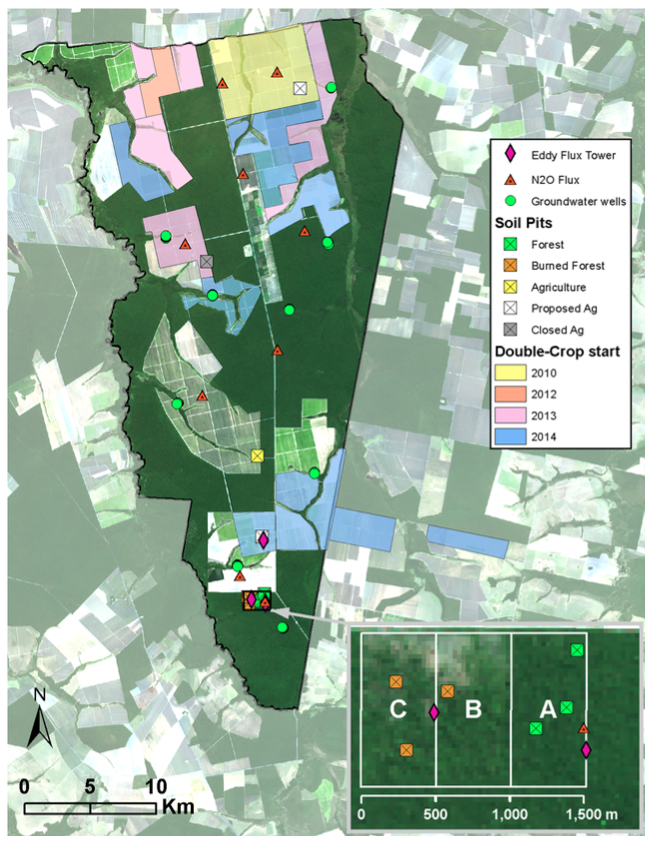

**Figure 1.** Map of study site Tanguro Ranch (courtesy Paul Leferve). Dark areas are forested parcels; light areas are agricultural fields. Soil pits (squares) sampled in this investigation include the southern three forest pits (green squares within forest block “A” in inset) and an agricultural forest pit (yellow square) in the southern half of the farm. Color overlay indicates what year soy/maize double cropping began, where applicable.

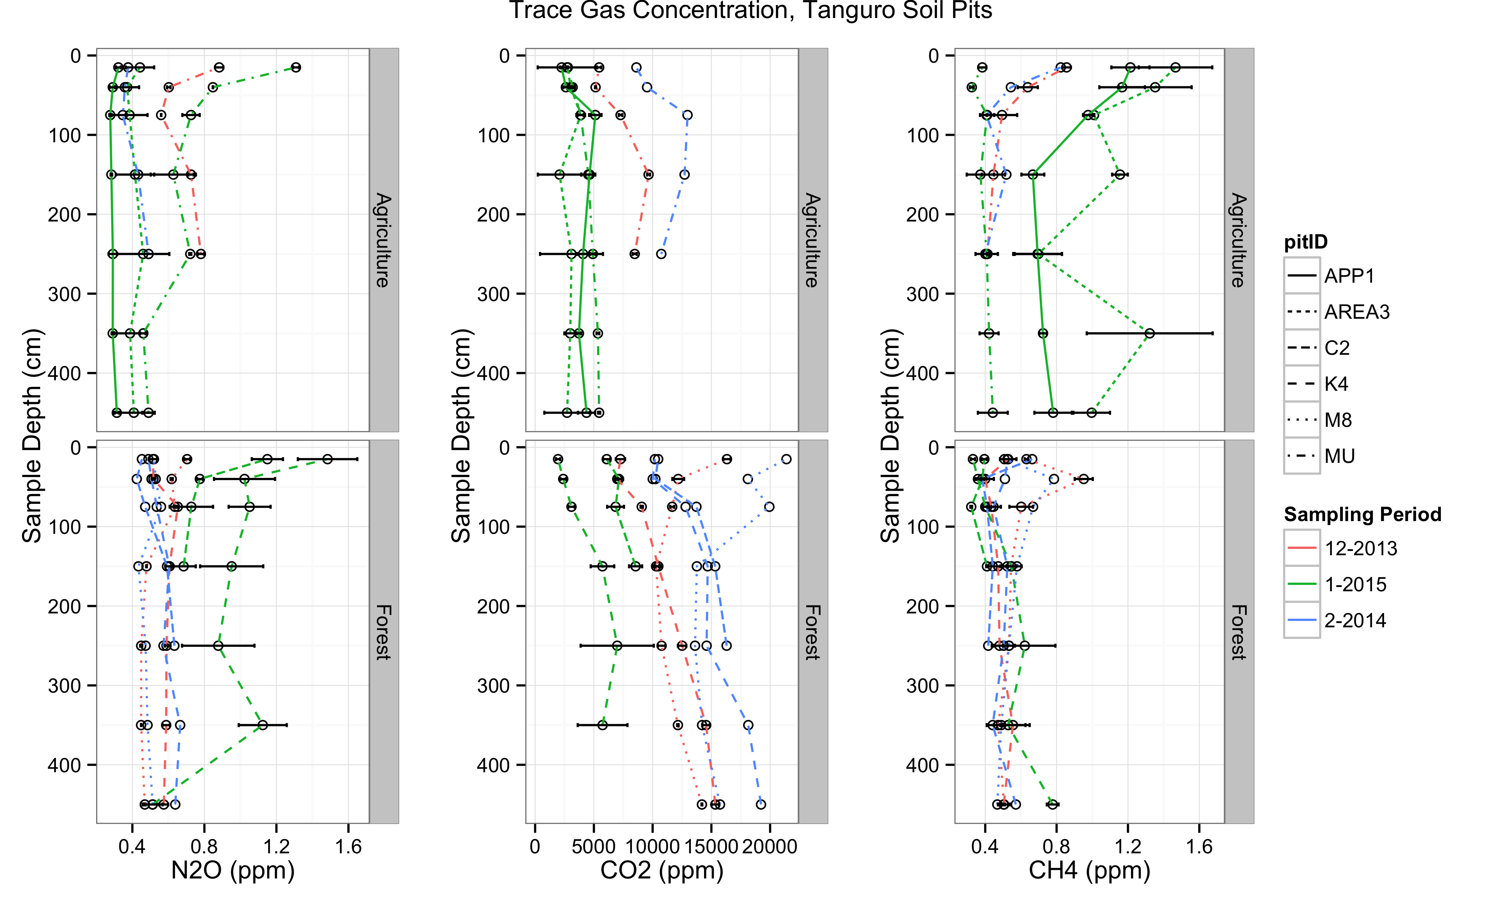

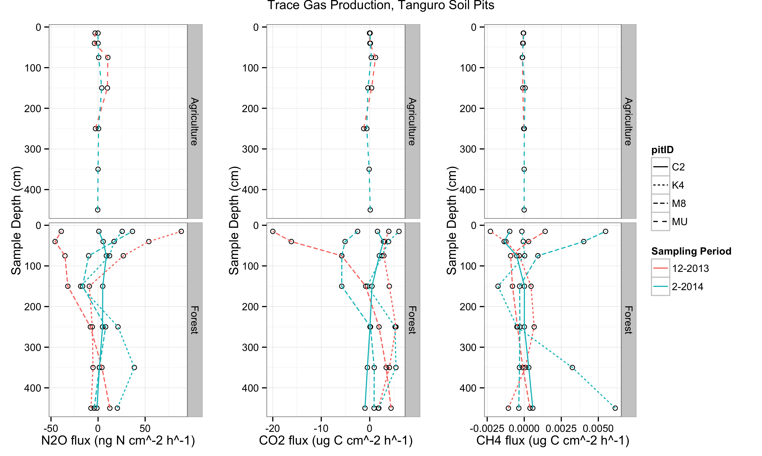

**Figure 2.** Standing concentration (ppm) of trace gases in soil pore space in soil pits at Tanguro Ranch (top panel) and gas production (ng N cm-2 h-1 or µg C cm-2 h-1). Color indicates sampling month and line type indicates the soil pit identity. Sampling was conducted in December 2013, February 2014 and January 2015. C2, K4 and M8 are located within intact forest, MU and APP1 are located within cultivated soybean, and Area3 is located in soybean/maize double-cropped cultivation. Error bars in the top panel represent the standard error of the multiple vials taken from each gas tube during a given field sampling.

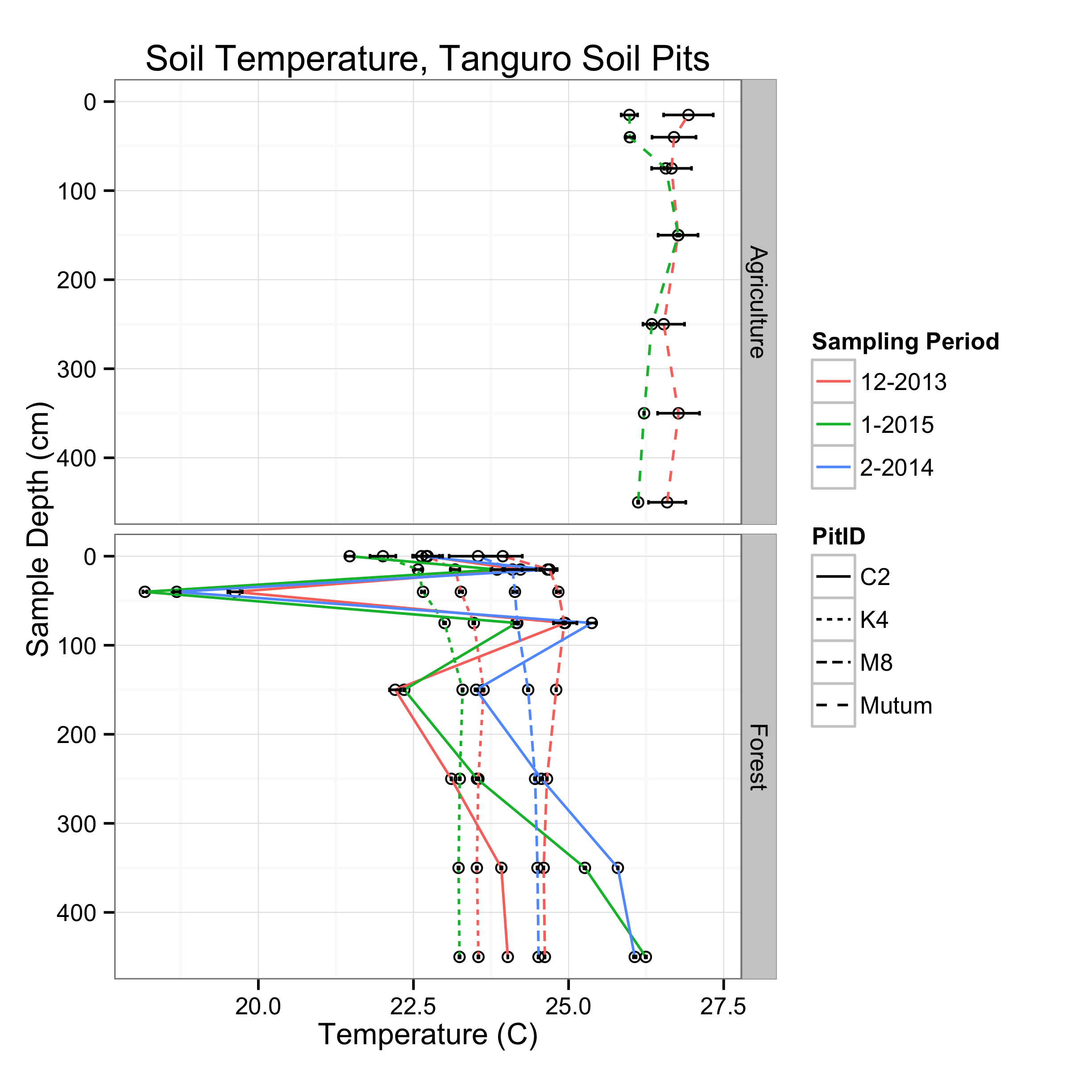

**Figure 3.** Soil temperature (C) in soil pits at Tanguro Ranch. Data are the mean and standard error of a week of thermocouple readings (taken every 6 hours) for the sampling months when gas samples were collected. Line style represents soil pit identification: C2, K4 and M8 are located within intact forest; MU is located within cultivated soybean.

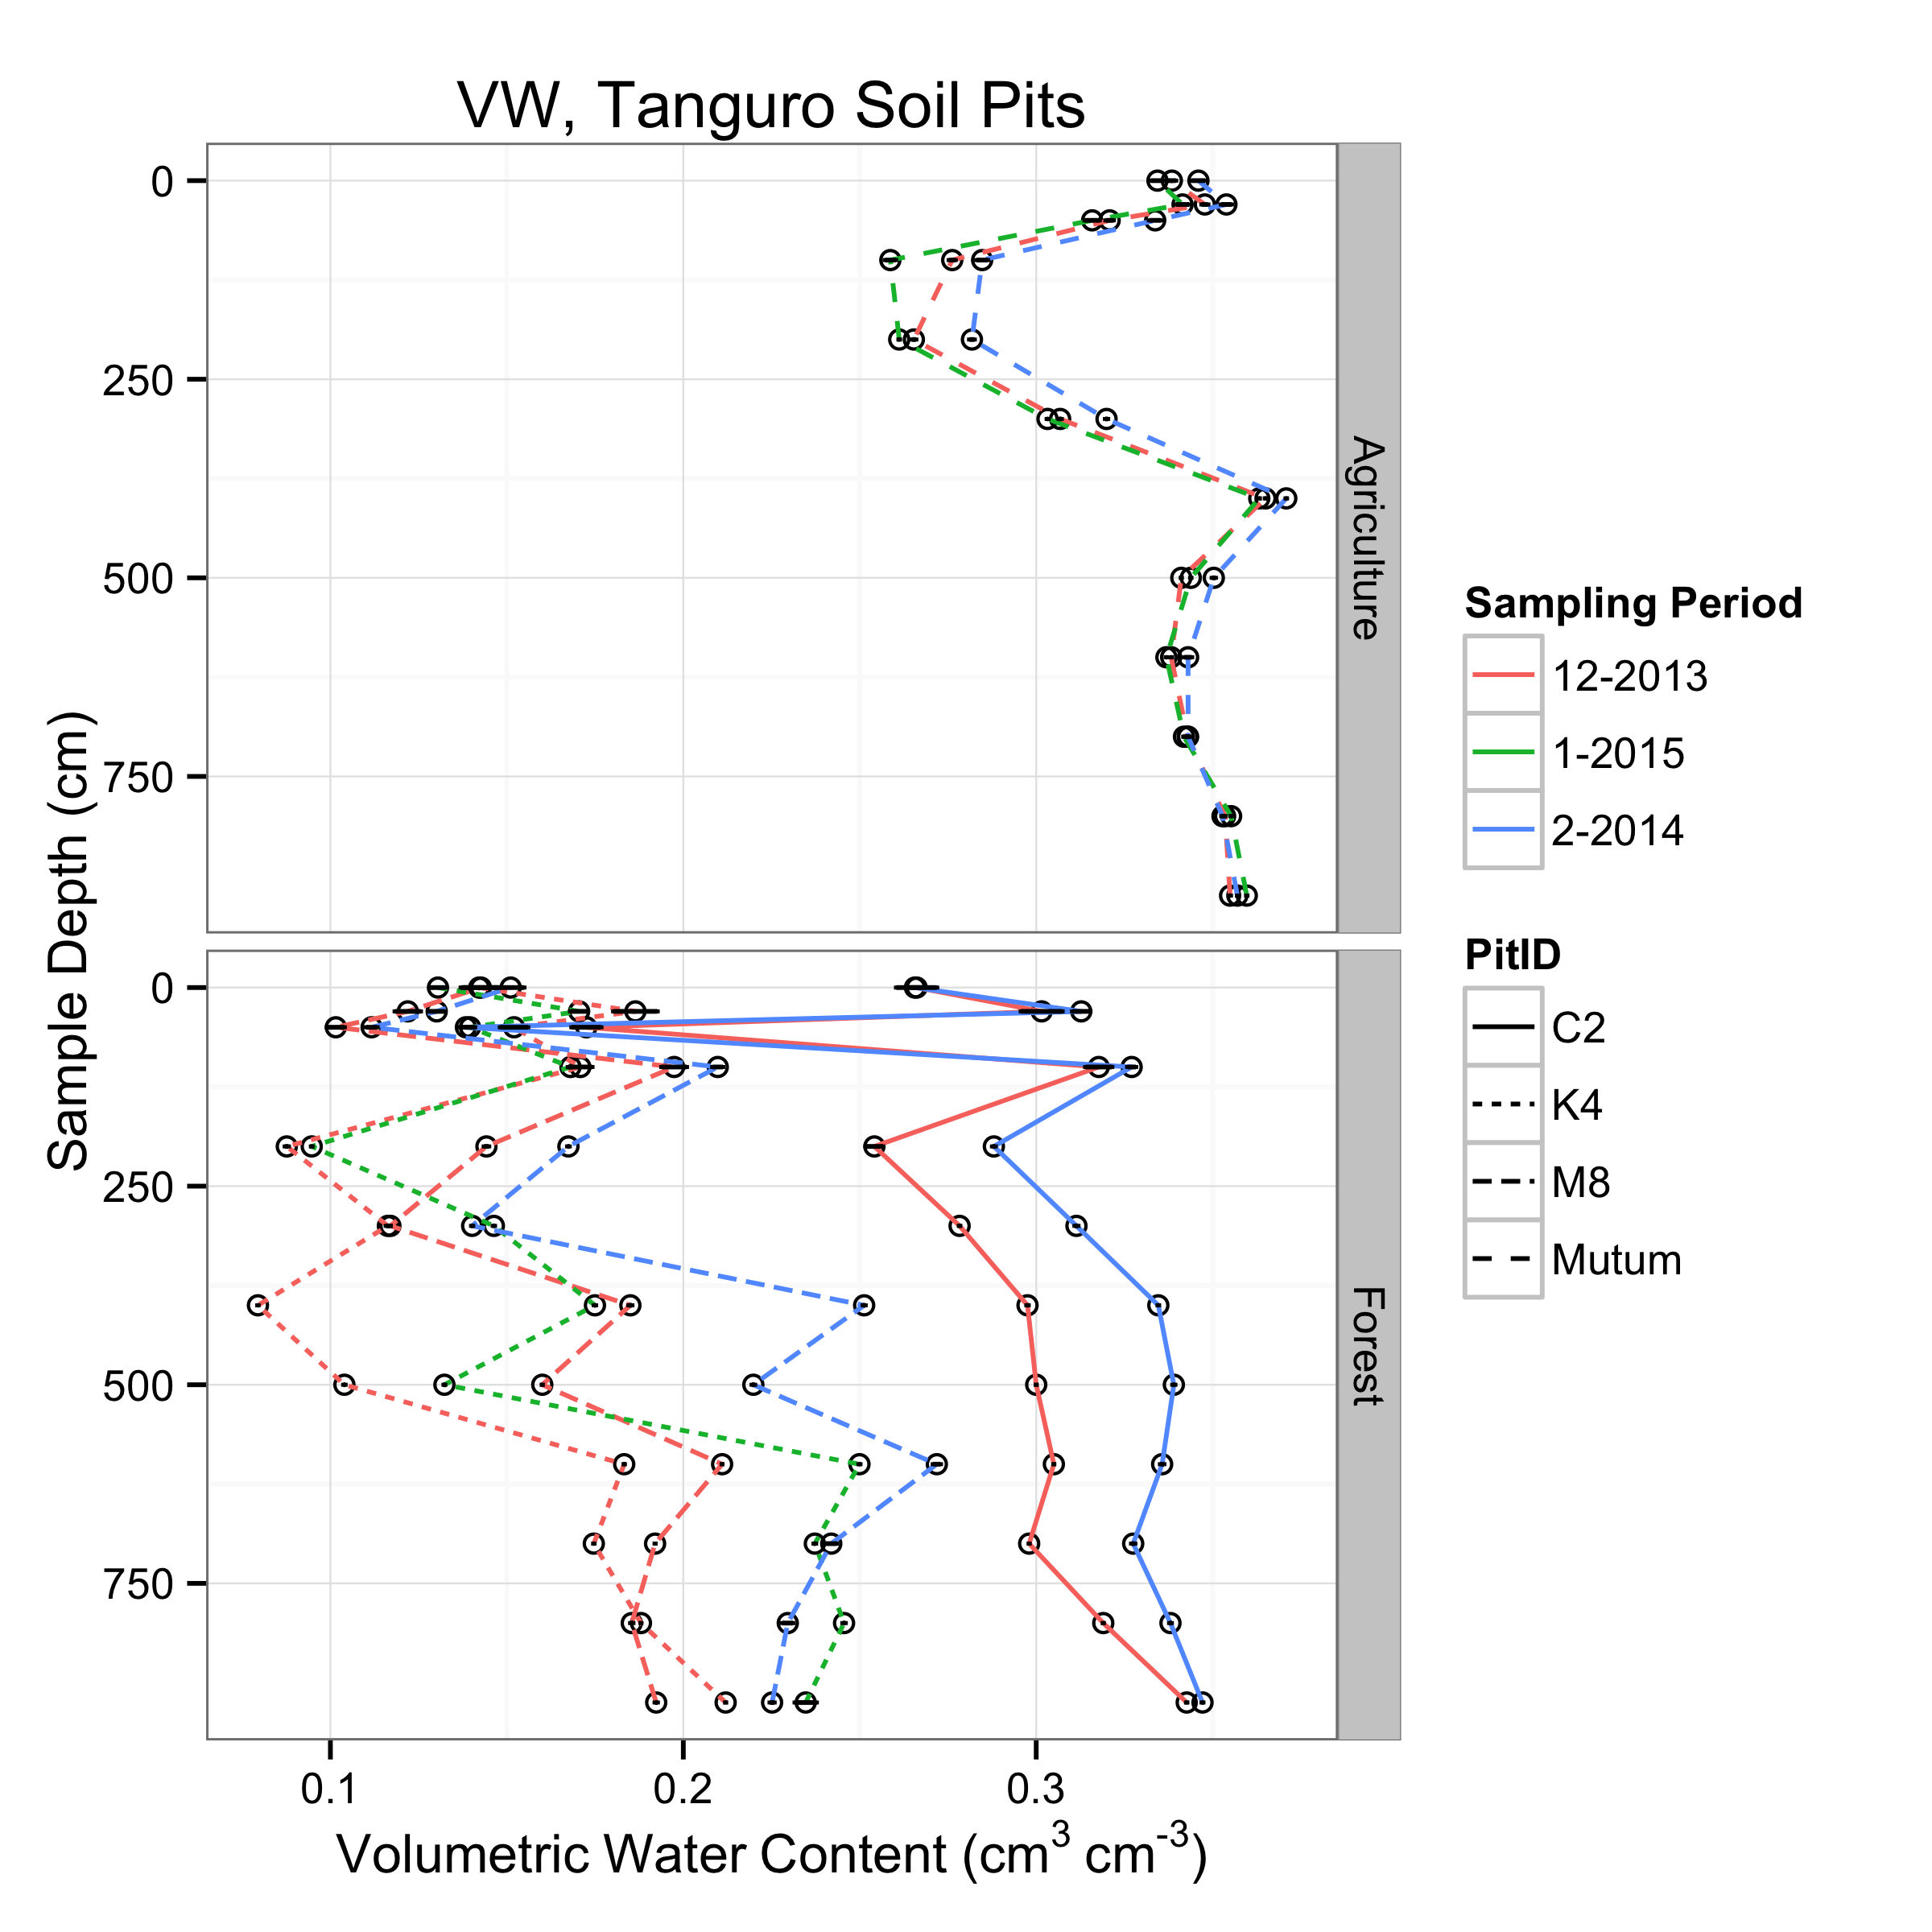

**Figure 4.** Soil volumetric water content (cm3 cm-3) in soil pits at Tanguro Ranch. Data are the mean and standard error of a week of TDR readings (taken every 6 hours) for the sampling months when gas samples were collected. Line style represents soil pit identification: C2, K4 and M8 are located within intact forest; MU is located within cultivated soybean.

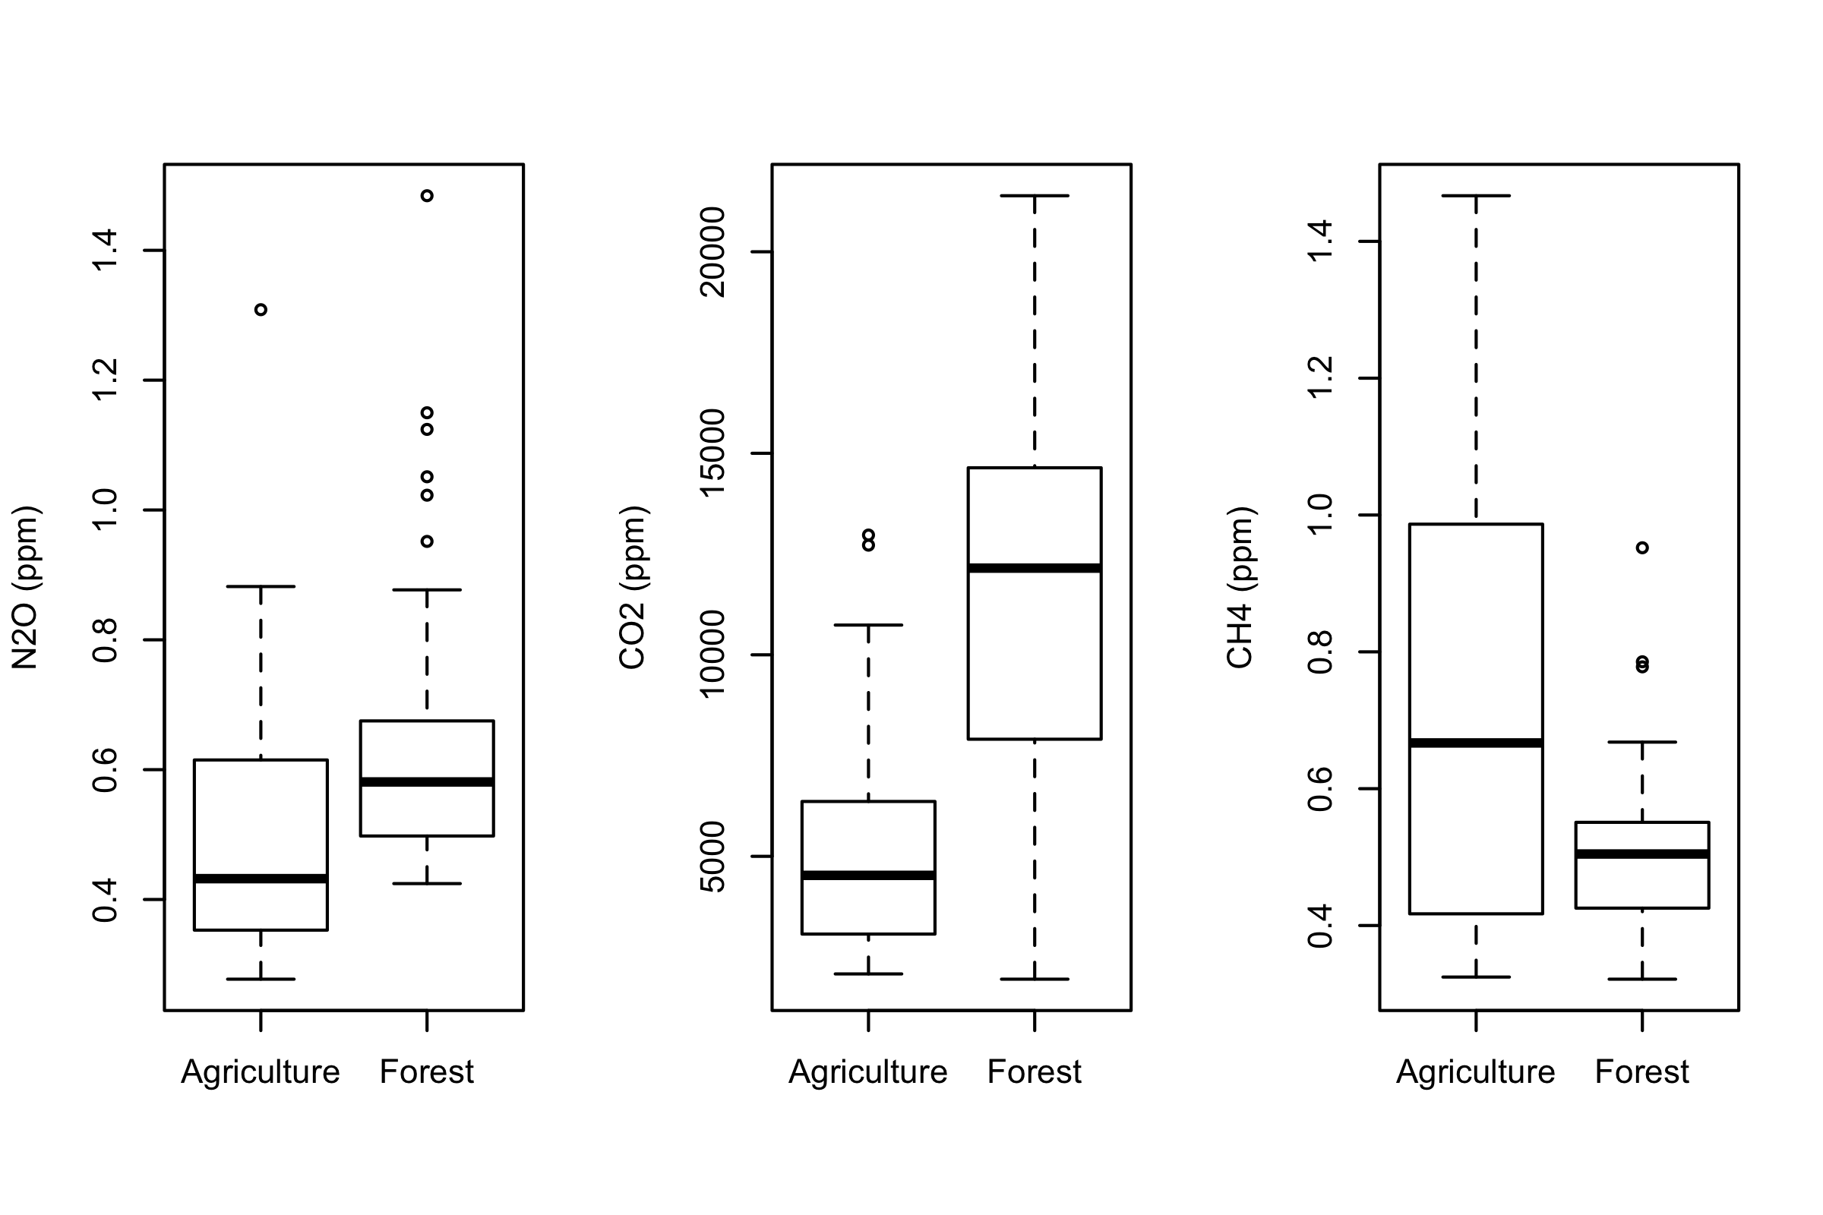

**Figure 5.** Boxplots comparing trace gas concentration between land uses. All three plots have significant differences between land uses (p < 0.001).

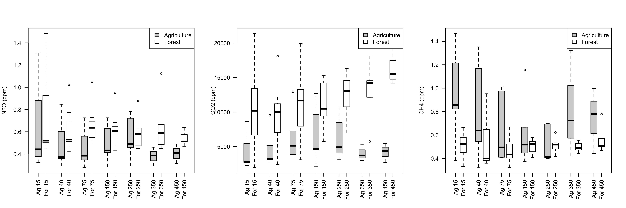

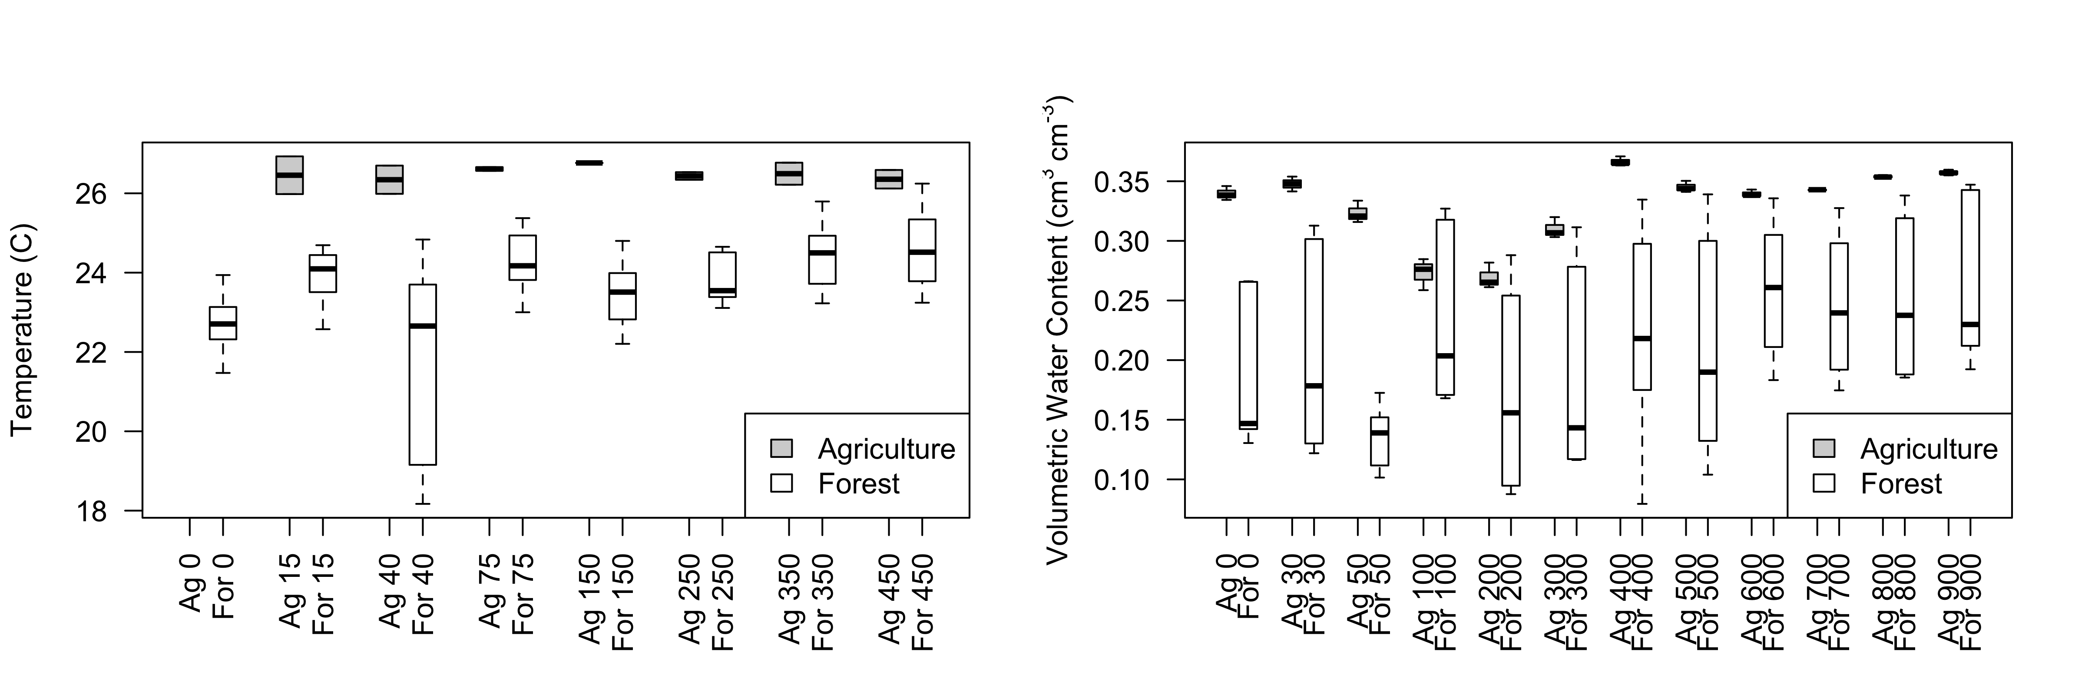

**Figure 6.** Boxplots comparing trace gas concentration, temperature and VWC between land uses, grouped by soil pit depth.

|  |  |  |  |  |  |
| --- | --- | --- | --- | --- | --- |
|  | Df | Sum Sq | Mean Sq | F value | Pr(>F) |
| LUType | 1 | 93.39772723 | 93.39772723 | 77.44507227 | 6.03E-12 |
| sampledepth | 7 | 40.15772602 | 5.736818003 | 4.756949639 | 0.00033444 |
| LUType:PitID | 2 | 15.61839809 | 7.809199043 | 6.475360827 | 0.003047842 |
| LUType:sampledepth | 6 | 9.164937173 | 1.527489529 | 1.266589032 | 0.288534564 |
| Residuals | 53 | 63.91729516 | 1.205986701 |  |  |
| fit <- aov( temp ~ LUType + LUType/PitID + sampledepth + LUType:sampledepth, data=pitmodeldf) | | | | | |

**Table 1.** Nested ANOVA table comparing the variation in soil temperature between groups.

|  |  |  |  |  |  |
| --- | --- | --- | --- | --- | --- |
|  | Df | Sum Sq | Mean Sq | F value | Pr(>F) |
| LUType | 1 | 0.331959651 | 0.331959651 | 392.9886056 | 5.08E-33 |
| sampledepth | 11 | 0.097669134 | 0.008879012 | 10.51136964 | 9.72E-12 |
| LUType:PitID | 2 | 0.254169885 | 0.127084942 | 150.4488094 | 3.63E-28 |
| LUType:sampledepth | 11 | 0.033887743 | 0.003080704 | 3.64707432 | 0.00031479 |
| Residuals | 82 | 0.069265854 | 0.000844706 |  |  |
| fit <- aov( VWC ~ LUType + LUType/PitID + sampledepth + LUType:sampledepth, data=pitmodeldf) | | | | | |

**Table 2.** Nested ANOVA table comparing the variation in VWC between groups.

|  |  |  |  |  |  |
| --- | --- | --- | --- | --- | --- |
|  | Df | Sum Sq | Mean Sq | F value | Pr(>F) |
| LUType | 1 | 1.383823892 | 1.383823892 | 16.69279246 | 0.000139007 |
| sampledepth | 6 | 0.485797753 | 0.080966292 | 0.976680285 | 0.449449326 |
| LUType:PitID | 4 | 3.045569047 | 0.761392262 | 9.184523469 | 8.47E-06 |
| LUType:sampledepth | 6 | 0.167475003 | 0.027912501 | 0.336702944 | 0.91467438 |
| Residuals | 57 | 4.725270621 | 0.082899485 |  |  |
| fit <- aov(log(meanN2Oppm) ~ LUType + LUType/PitID + sampledepth + LUType:sampledepth, data=pitmodeldf) | | | | | |

**Table 3.** Regression table with ppm N2O as the response variable.

|  |  |  |  |  |  |
| --- | --- | --- | --- | --- | --- |
|  | Df | Sum Sq | Mean Sq | F value | Pr(>F) |
| LUType | 1 | 11.22540656 | 11.22540656 | 53.57726297 | 1.03E-09 |
| sampledepth | 6 | 1.553979873 | 0.258996646 | 1.236154014 | 0.301990771 |
| LUType:PitID | 4 | 6.076317192 | 1.519079298 | 7.250348623 | 8.89E-05 |
| LUType:sampledepth | 6 | 0.611928407 | 0.101988068 | 0.486774488 | 0.81545484 |
| Residuals | 56 | 11.73301383 | 0.209518104 |  |  |
| fit <- aov(log(meanCO2ppm) ~ LUType + LUType/PitID + sampledepth + LUType:sampledepth, data=pitmodeldf) | | | | | |

**Table 4.** Regression table with ppm CO2 as the response variable.

|  |  |  |  |  |  |
| --- | --- | --- | --- | --- | --- |
|  | Df | Sum Sq | Mean Sq | F value | Pr(>F) |
| LUType | 1 | 1.344012867 | 1.344012867 | 30.52778917 | 8.50E-07 |
| sampledepth | 6 | 0.497926902 | 0.082987817 | 1.884977922 | 0.099139657 |
| LUType:PitID | 4 | 4.927415846 | 1.231853962 | 27.98022172 | 7.11E-13 |
| LUType:sampledepth | 6 | 0.508708212 | 0.084784702 | 1.925792207 | 0.092141999 |
| Residuals | 57 | 2.509475318 | 0.044025883 |  |  |
| fit <- aov(log(meanCH4ppm) ~ LUType + LUType/PitID + sampledepth + LUType:sampledepth, data=pitmodeldf) | | | | | |

**Table 5.** Regression table with ppm CH4 as the response variable.

**Table 6.** Differences between trace gas fluxes and soil variables between land uses and seasons; data courtesy O’Connell et. al 2015 (Chapter 3 of this document). Responses are reported as mean and standard deviation (in parentheses) values. NS indicated an insignificant difference between groups (one-way ANOVA), while ** indicated a significant model, p<0.01. Letters indicate which groups were significantly different (Tukey’s HSD post-hoc test).

|  |  |  |  |  |
| --- | --- | --- | --- | --- |
| **Land Use** | **Season** | **N2O Flux**  **(ng N cm-2 h-1) NS** | **CO2 Flux**  **(μg C cm-2 h-1) \*\*** | **CH4 Flux**  **(μg C cm-2 h-1) NS** |
| Forest | Wet | 1.383691 (1.813256208) | 13.59264 (4.386105812) a | -0.0002809052 (0.006081409) |
| Soybean/Maize | Wet | 1.671915 (4.771374396) | 16.84562 (12.176281566) a | -0.0004615075 (0.001392989) |
| Soybean | Wet | 0.8115679 (1.165351991) | 22.226 (20.234899779) b | -0.0004677696 (0.005359183) |

**References and Notes:**

1. J. S. Powers, M. D. Corre, T. E. Twine, E. Veldkamp, Geographic bias of field observations of soil carbon stocks with tropical land-use changes precludes spatial extrapolation, *Proceedings of the National Academy of Sciences* **108**, 6318–6322 (2011).

2. E. G. Jobbágy, R. B. Jackson, The distribution of soil nutrients with depth: global patterns and the imprint of plants, *Biogeochemistry* (2001).

3. E. Jobbágy, R. Jackson, The vertical distribution of soil organic carbon and its relation to climate and vegetation, *Ecological Applications* **10**, 423–436 (2000).

4. R. B. Harrison, P. W. Footen, B. D. Strahm, Deep soil horizons: contribution and importance to soil carbon pools and in assessing whole-ecosystem response to management and global change, *Forest Science* (2011).

5. D. C. Nepstad, C. R. de Carvalho, E. A. Davidson, P. H. Jipp, The role of deep roots in the hydrological and carbon cycles of Amazonian forests and pastures, (1994).

6. C. Rumpel, I. Kögel-Knabner, Deep soil organic matter—a key but poorly understood component of terrestrial C cycle, *Plant Soil* **338**, 143–158 (2010).

7. E. D. SOTTA *et al.*, Effects of an induced drought on soil carbon dioxide (CO 2) efflux and soil CO 2production in an Eastern Amazonian rainforest, Brazil, *Global Change Biol* **13**, 2218–2229 (2007).

8. C. Neill, M. C. Piccolo, C. C. Cerri, P. A. Steudler, J. M. Melillo, Soil Solution Nitrogen Losses During Clearing of Lowland Amazon Forest for Pasture, *Plant Soil* **281**, 233–245 (2006).

9. K. G. Eilers, S. Debenport, S. Anderson, N. Fierer, Soil Biology & Biochemistry, *Soil Biology and Biochemistry* **50**, 58–65 (2012).

10. C. Neill, M. C. Piccolo, J. M. Melillo, P. A. Steudler, Nitrogen dynamics in Amazon forest and pasture soils measured by 15 N pool dilution, *Soil Biology and …* (1999).

11. V. S. Melo *et al.*, Consequences of forest conversion to pasture and fallow on soil microbial biomass and activity in the eastern Amazon, *Soil Use and Management* **28**, 530–535 (2012).

12. M. Keller *et al.*, Soil-atmosphere exchange of nitrous oxide, nitric oxide, methane, and carbon dioxide in logged and undisturbed forest in the Tapajos National Forest, Brazil, *Earth Interactions* **9**, 1–28 (2005).

13. M. C. Piccolo, F. Andreux, C. C. Cerri, HYDROCHEMISTRY OF SOIL SOLUTION COLLECTED WITH TENSION-FREE LYSIMETERS IN NATIVE AND CUT-AND-BRUNED TROPICAL RAIN FOREST …, *Geochimica Brasiliensis* (2011).

14. M. R. Williams, T. R. Fisher, J. M. Melack, Solute dynamics in soil water and groundwater in a central Amazon catchment undergoing deforestation, *Biogeochemistry* (1997).

15. L. Schwendenmann, E. PENDALL, Effects of forest conversion into grassland on soil aggregate structure and carbon storage in Panama: evidence from soil carbon fractionation and stable isotopes, *Plant Soil* (2006).

16. E. Veldkamp, A. Becker, L. Schwendenmann, Substantial labile carbon stocks and microbial activity in deeply weathered soils below a tropical wet forest, *Global Change Biol* (2003).

17. E. Marin-Spiotta, W. L. Silver, C. Swanston, R. ostertag, Soil organic matter dynamics during 80 years of reforestation of tropical pastures, *Global Change Biol* (2009).

18. L. Schwendenmann, E. Veldkamp, G. Moser, Effects of an experimental drought on the functioning of a cacao agroforestry system, Sulawesi, Indonesia, *Global Change Biol* (2010).

19. S. J. HAYHOE *et al.*, Conversion to soy on the Amazonian agricultural frontier increases streamflow without affecting stormflow dynamics, *Global Change Biol* **17**, 1821–1833 (2011).

20. M. N. Macedo *et al.*, Decoupling of deforestation and soy production in the southern Amazon during the late 2000s, *Proceedings of the National Academy of Sciences* **109**, 20120171–20120171 (2012).

21. R. DeFries, M. Herold, L. Verchot, M. N. Macedo, Y. Shimabukuro, Export-oriented deforestation in Mato Grosso: harbinger or exception for other tropical forests? *Philosophical Transactions of the Royal Society B: Biological Sciences* **368**, 20120173–20120173 (2013).

22. J. K. Balch *et al.*, Negative fire feedback in a transitional forest of southeastern Amazonia, *Global Change Biol* **14**, 2276–2287 (2008).

23. P. M. Brando *et al.*, Abrupt increases in Amazonian tree mortality due to drought-fire interactions, *Proceedings of the National Academy of Sciences* **111**, 6347–6352 (2014).

24. R. T. Venterea, M. Burger, K. A. Spokas, Nitrogen Oxide and Methane Emissions under Varying Tillage and Fertilizer Management, *Journal of Environment Quality* **34**, 1467 (2005).

25. E. A. Davidson, K. E. Savage, S. E. Trumbore, Vertical partitioning of CO2 production within a temperate forest soil, *Global Change …* (2006), doi:10.1111/j.1365-2486.2006.01142.x.

26. E. A. Davidson, S. E. Trumbore, Gas diffusivity and production of CO2 in deep soils of the eastern Amazon, *Tellus B* (1995).

27. T. J. Blasing, Recent Greenhouse Gas Concentrations, (2009), doi:10.3334/CDIAC/atg.032.

28. S. H. Riskin *et al.*, The fate of phosphorus fertilizer in Amazon soya bean fields, *Philosophical Transactions of the Royal Society B: Biological Sciences* **368**, 20120154–20120154 (2013).

29. K. Fujisaki *et al.*, From forest to cropland and pasture systems: a critical review of soil organic carbon stocks changes in Amazonia, *Global Change Biol* **21**, 2773–2786 (2015).

30. J. L. Rodrigues *et al.*, Conversion of the Amazon rainforest to agriculture results in biotic homogenization of soil bacterial communities, *Proceedings of the National Academy of Sciences of the United States of America* **110**, 988–993 (2013).

31. E. L. Madsen, Microorganisms and their roles in fundamental biogeochemical cycles, *Current Opinion in Biotechnology* **22**, 456–464 (2011).

32. R. T. Venterea *et al.*, Challenges and opportunities for mitigating nitrous oxide emissions from fertilized cropping systems, *Frontiers in Ecology and the Environment* **10**, 562–570 (2012).

33. B. Koehler, E. Zehe, M. D. Corre, E. Veldkamp, An inverse analysis reveals limitations of the soil-CO2 profile method to calculate CO2 production and efflux for well-structured soils, *Biogeosciences* **7**, 2311–2325 (2010).

34. L. Schwendenmann, E. Veldkamp, Long‐term CO2 production from deeply weathered soils of a tropical rain forest: Evidence for a potential positive feedback to climate warming, *Global Change Biol* (2006).

35. L. Schwendenmann, E. Veldkamp, T. Brenes, J. J. O'Brien, Spatial and temporal variation in soil CO2 efflux in an old-growth neotropical rain forest, La Selva, Costa Rica, *Biogeochemistry* (2003).

36. P. M. Groffman *et al.*, Methods for measuring denitrification: diverse approaches to a difficult problem, *Ecol Appl* **16**, 2091–2122 (2006).

37. P. M. Groffman *et al.*, Challenges to incorporating spatially and temporally explicit phenomena (hotspots and hot moments) in denitrification models, *Biogeochemistry* **93**, 49–77 (2009).

**Supplemental Figures:**

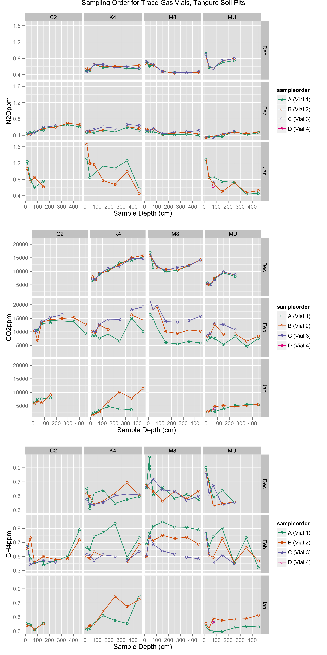

**Supplemental Figure S1.** Standing concentration (ppm) of trace gases in soil pore space in soil pits at Tanguro Ranch. Colors indicate the order in which the vial was sampled (approximately 1 minute gap between samples), used to assess whether samples were in good agreement.

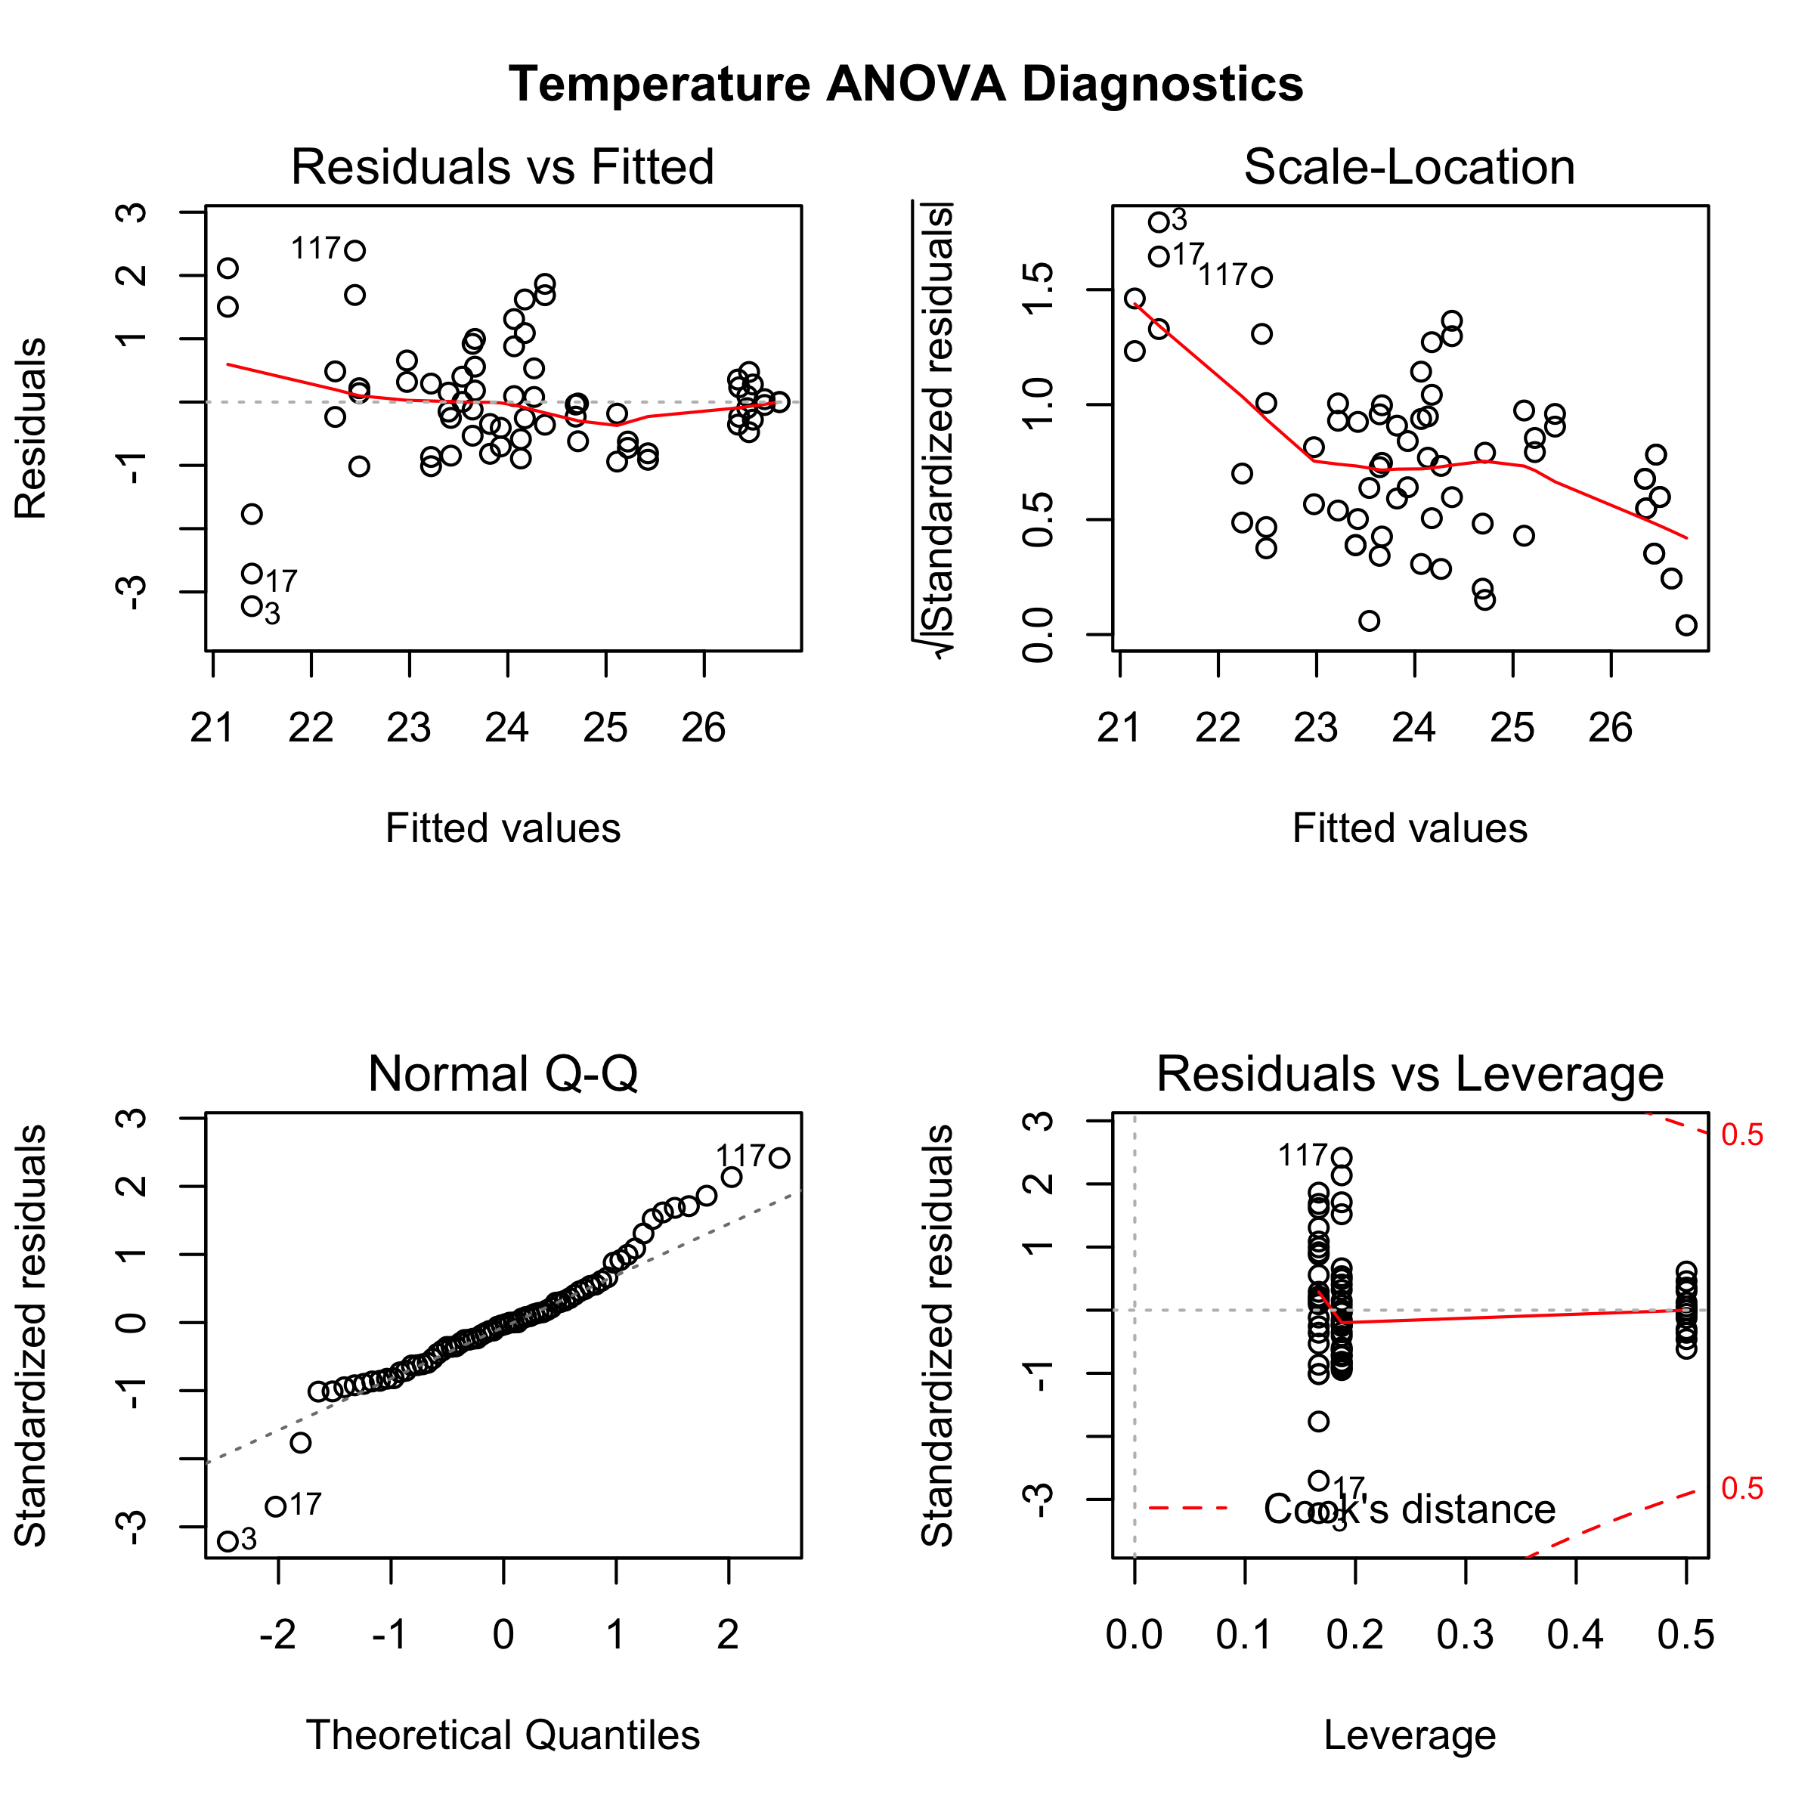 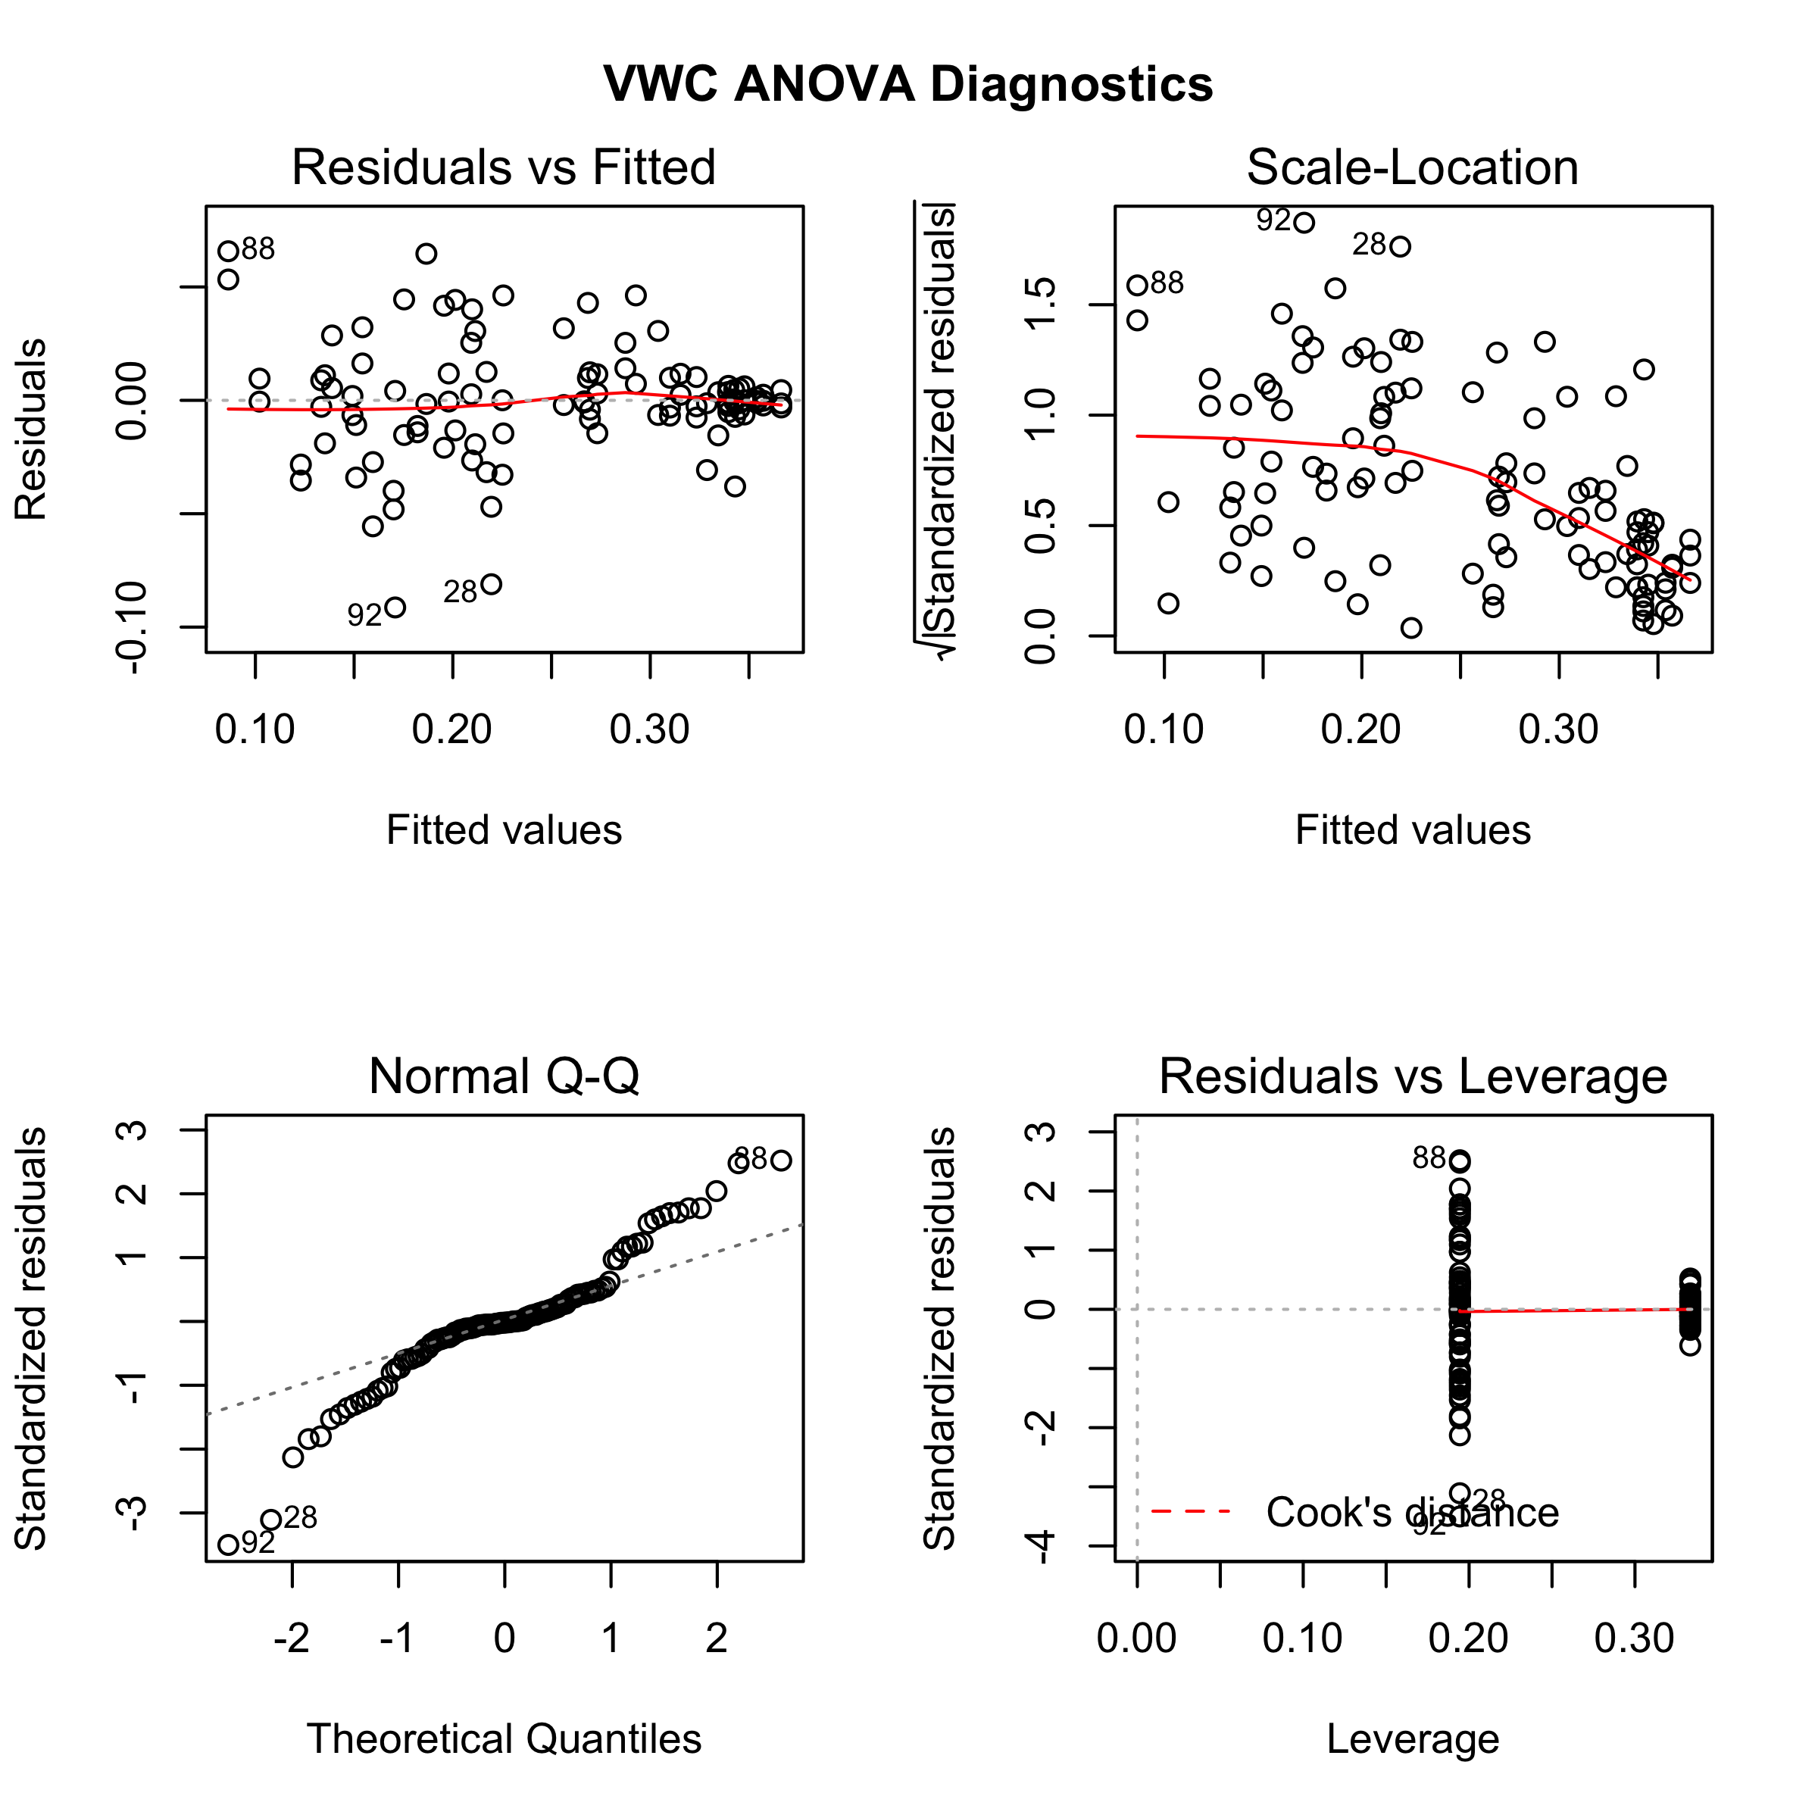

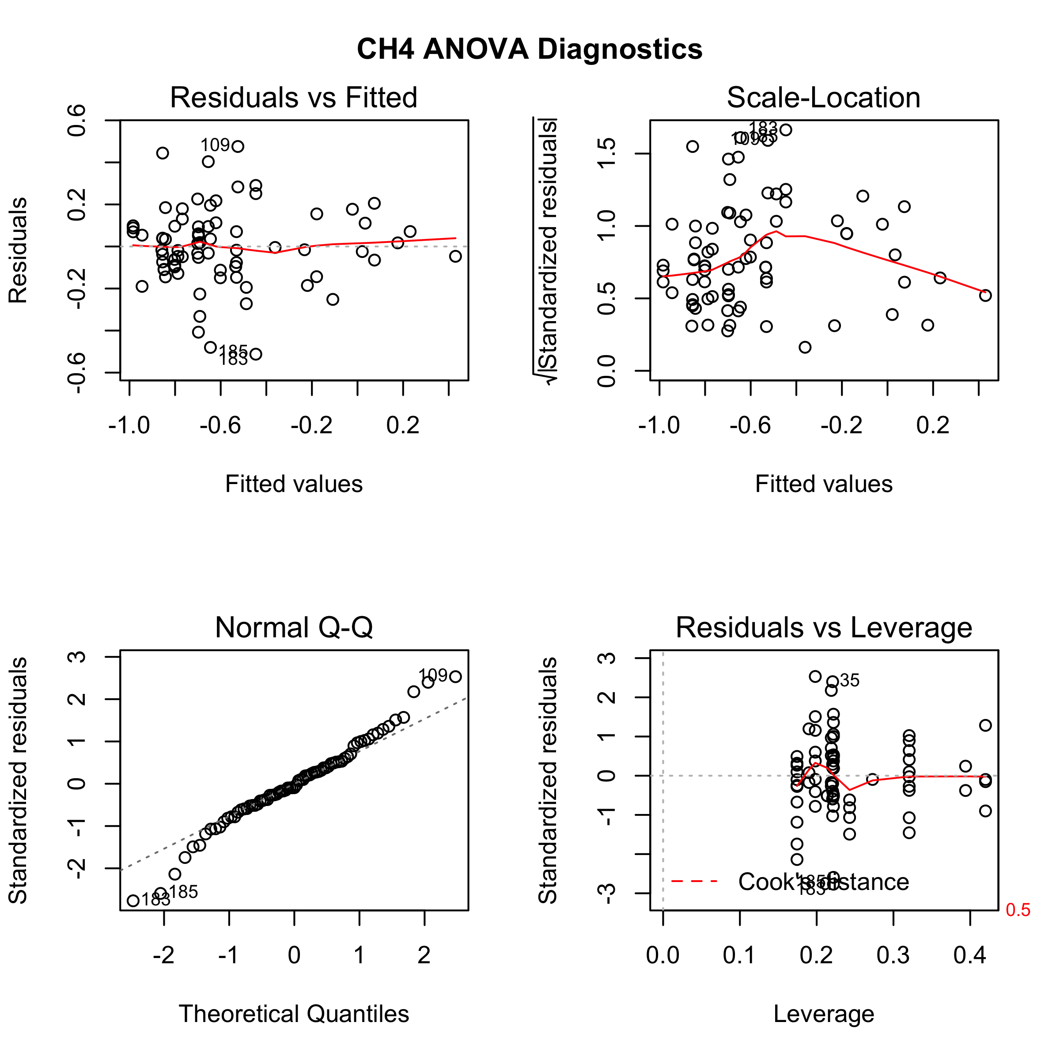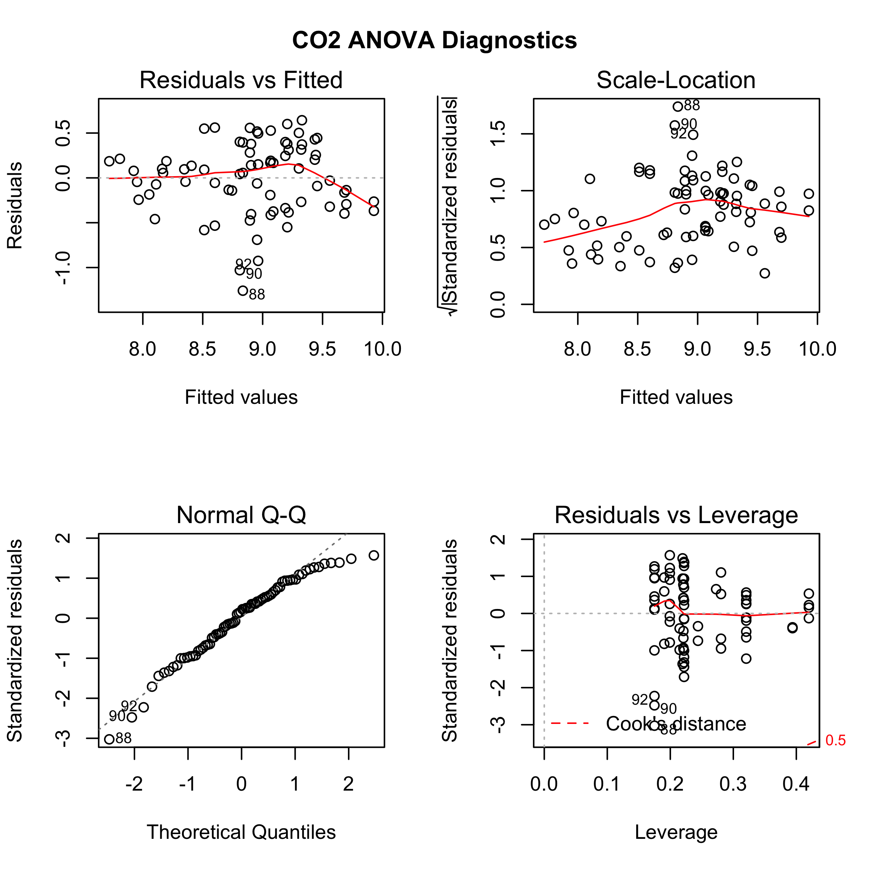

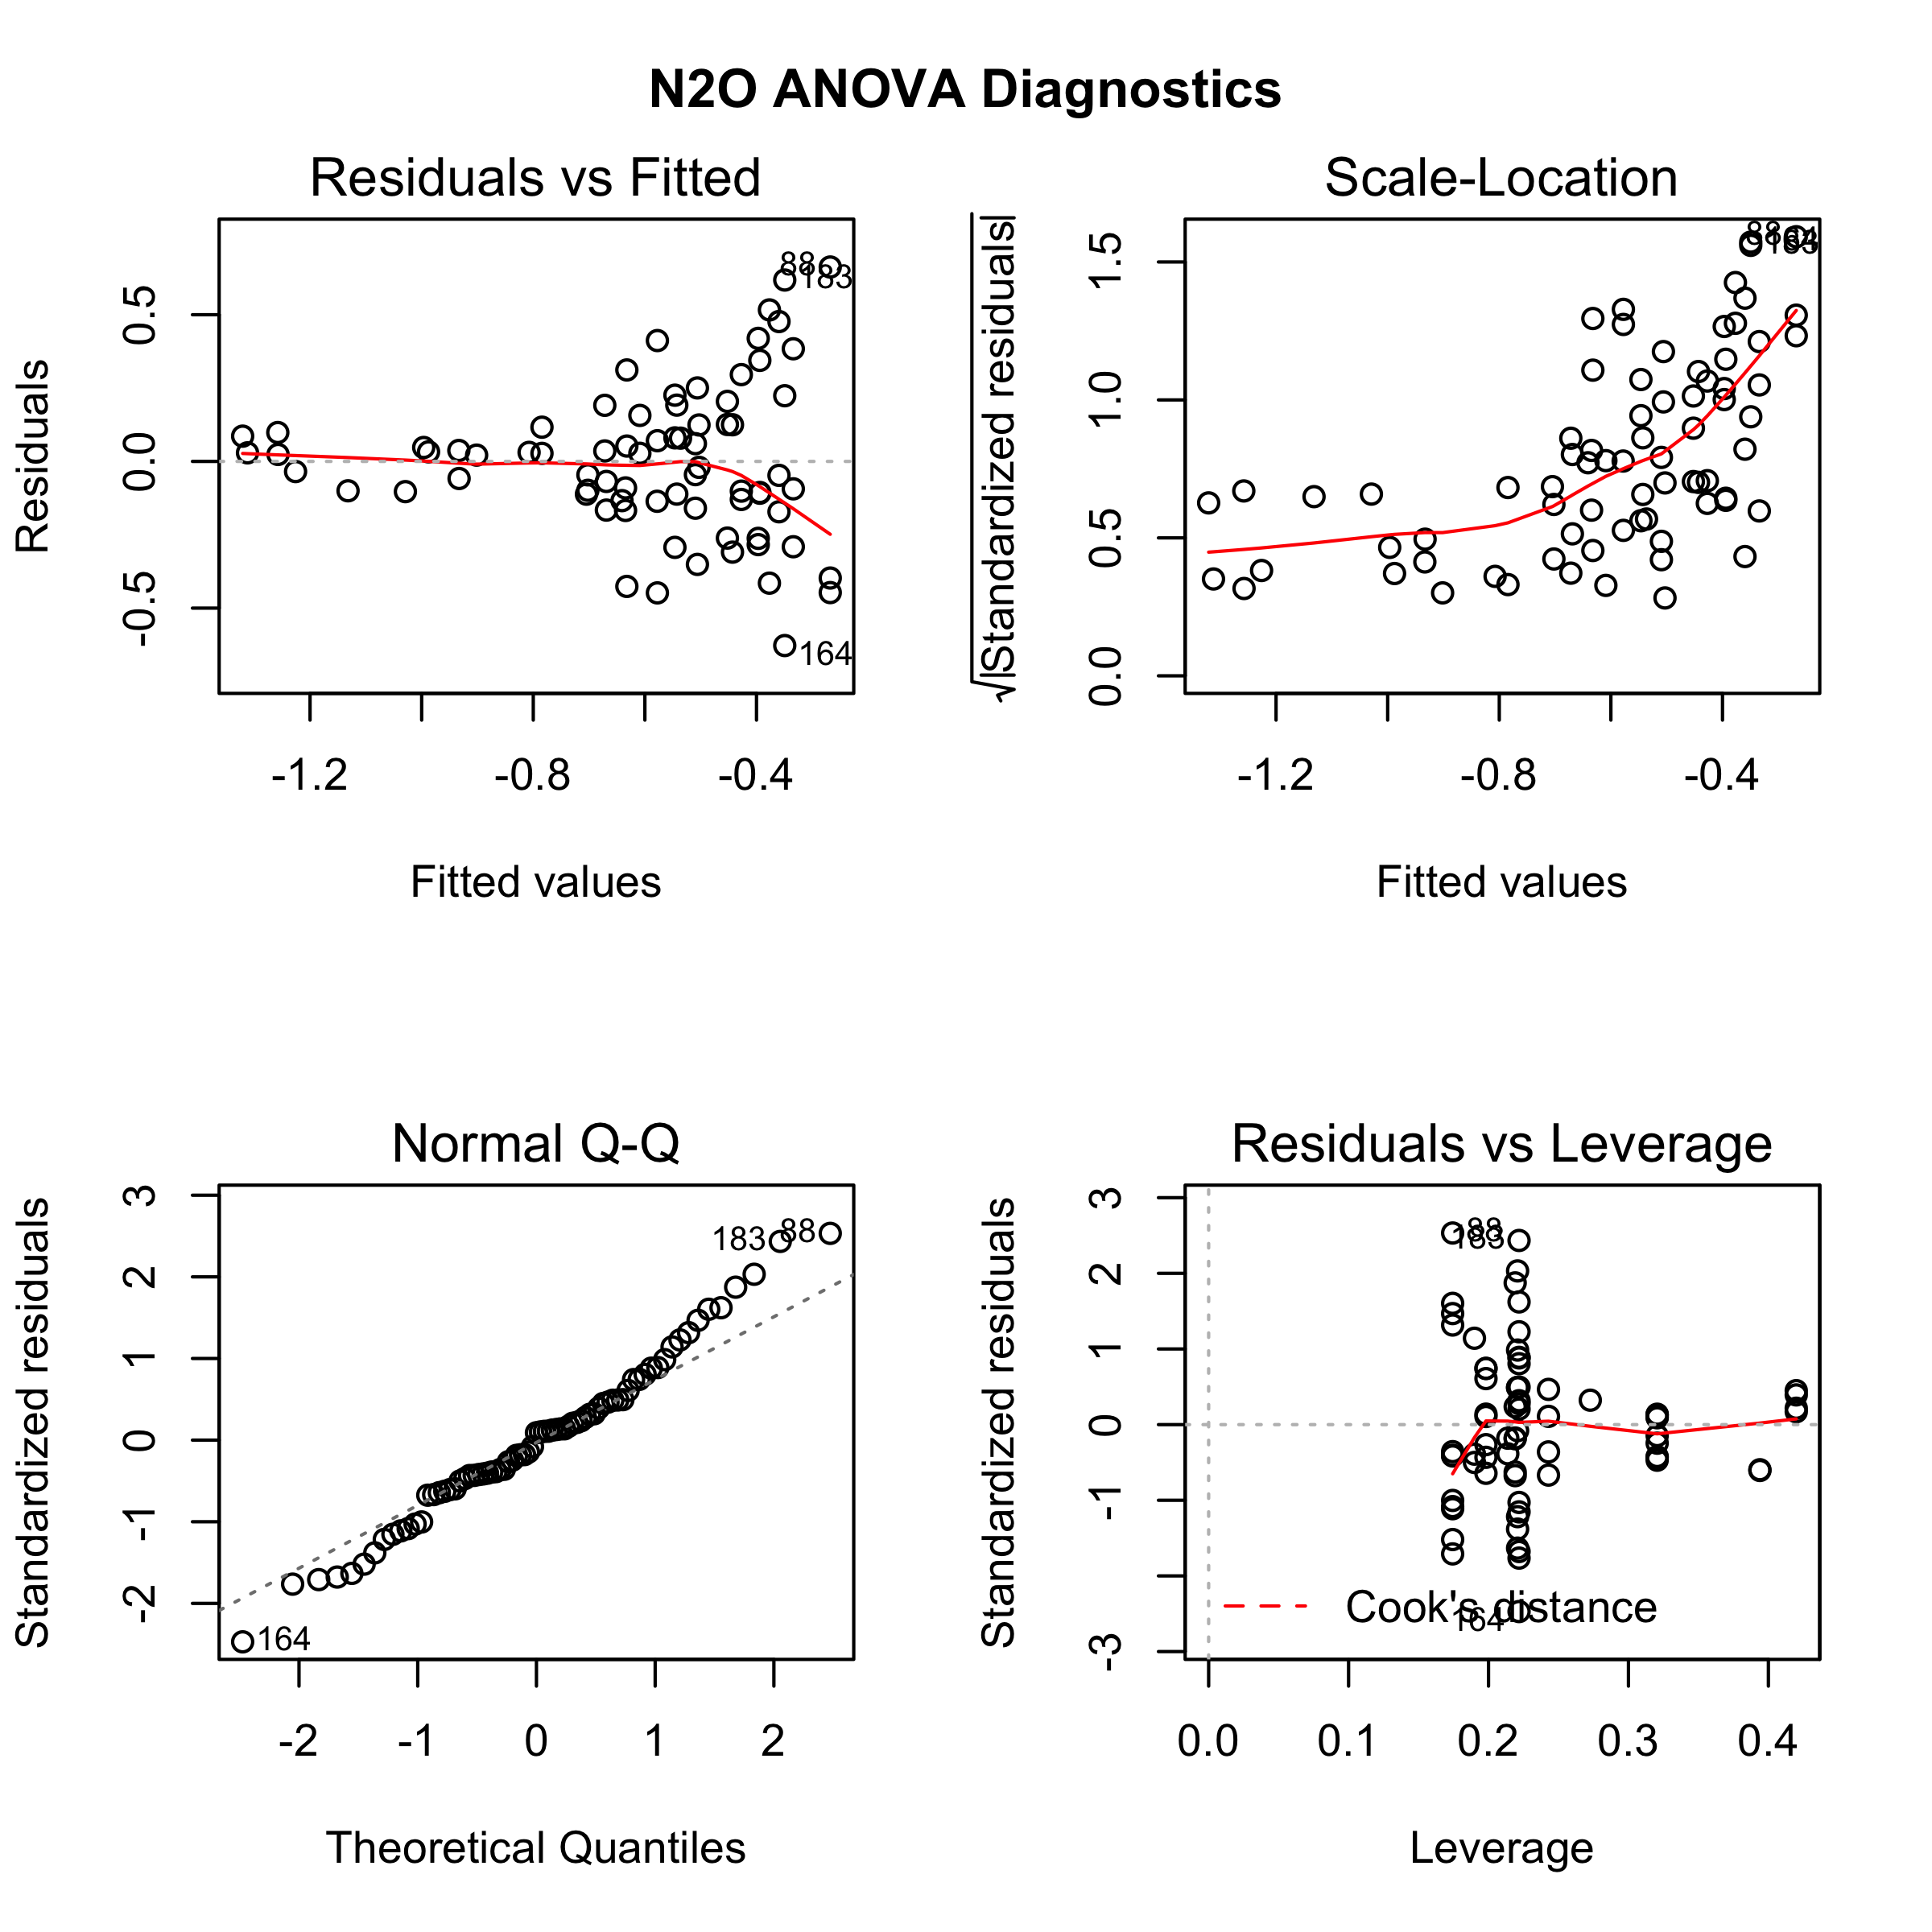

**Supplemental Figure S2.** Diagnostic plots for nested ANOVAs comparing differences measured variables between land uses. The model is a nested design where pit is nested within land use (land use is fixed, pit is random); sample depth and land use are both factors. Sample depth * land use interaction should be included because these are both fixed effects; pit * land use interaction should not be included because that interaction is confounded by the nested pit effect. In all cases, the model is:

aov(Measurement ~ LUType + LUType/PitID + sampledepth + LUType:sampledepth)

Since this experimental design is currently unbalanced, normally we can't trust the p-values from a SS or MS table and we would need to use a Satterthwaite approximation. However, aov() (ANOVA function in R statistical software’s base package) handles unbalanced sampling internally and manual corrections for unbalanced sample sizes are unnecessary.

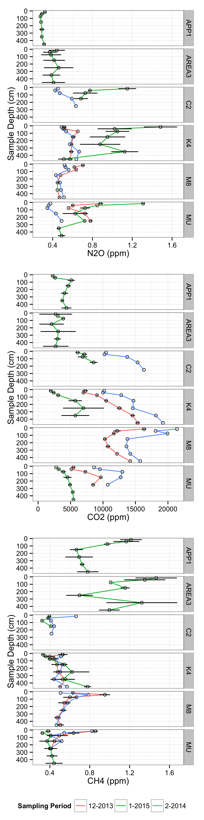

**Supplemental Figure S3.** Standing concentration (ppm) of trace gases in soil pore space in soil pits at Tanguro Ranch. Sampling was conducted in December 2013, February 2014 and January 2015. C2, K4 and M8 are located within intact forest, MU and APP1 are located within cultivated soybean, and Area3 is located in soybean/maize double-cropped cultivation. Error bars represent the standard error of the multiple vials taken from each gas tube during a given field sampling.

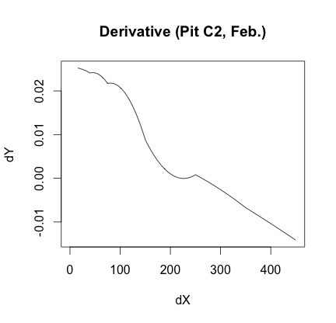 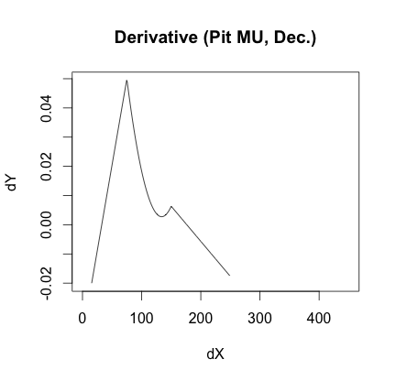

**Supplemental Figure S4.** Examples of the modeled CO2 concentration gradient, dC/dz, by depth for two pits sampled in a given month. These first derivative values were solved for from a LOESS local regression model to predict µg C cm-3 by depth.